Name __________________________________________________________Lab______ Block______
Molecular Basis of Heredity
- DNA Structure, Function and Replication
- Protein Synthesis and RNA Transcription
- Protein Synthesis and RNA Translation
- Genetic Mutations
DNA Structure, Function and Replication
Objectives
Explain that DNA replication take place during Interphase if the cell cycle
Explain that DNA replication takes place inside the nucleus
Explain that DNA is composed of a phosphate, sugar and nitrogen bases
Demonstrate the paring of adenine and thymine and the pairing of guanine and cytosine
Model the double helix composition of a DNA strand
Explain that the function of DNA is to store and replicate instructions to make the organism
Explain the process of DNA replicating a strand

NOTES
DNA Structure
DNA = ___________________________________________________________________
DNA is made up of___________ part __________________________________ containing:
- _________________________________________________________________
- _________________________________________________________________
- One of these four ______________________________ (also called nucleic acids):
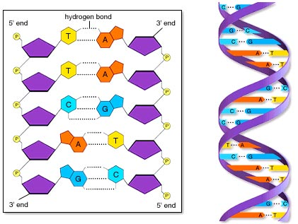
  - ______________________
  - ______________________
  - ______________________
  - ______________________

The nucleotides assemble forming a _______________ _____________ structure.

Instructions: Circle four nucleotides, one with each of the four bases, in each of the diagrams on the right.
Base Pairing Rules
_____________________ and ______________________ always pair, represented with an “A & T”
_____________________ and ______________________ always pair, represented with a “C & G”
Illustrate
Instructions: Color the two DNA models below. Use the same colors on each model so the model on the left side serves as a key for the model on the right. Remember the base pairing rules.
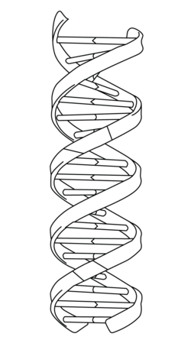
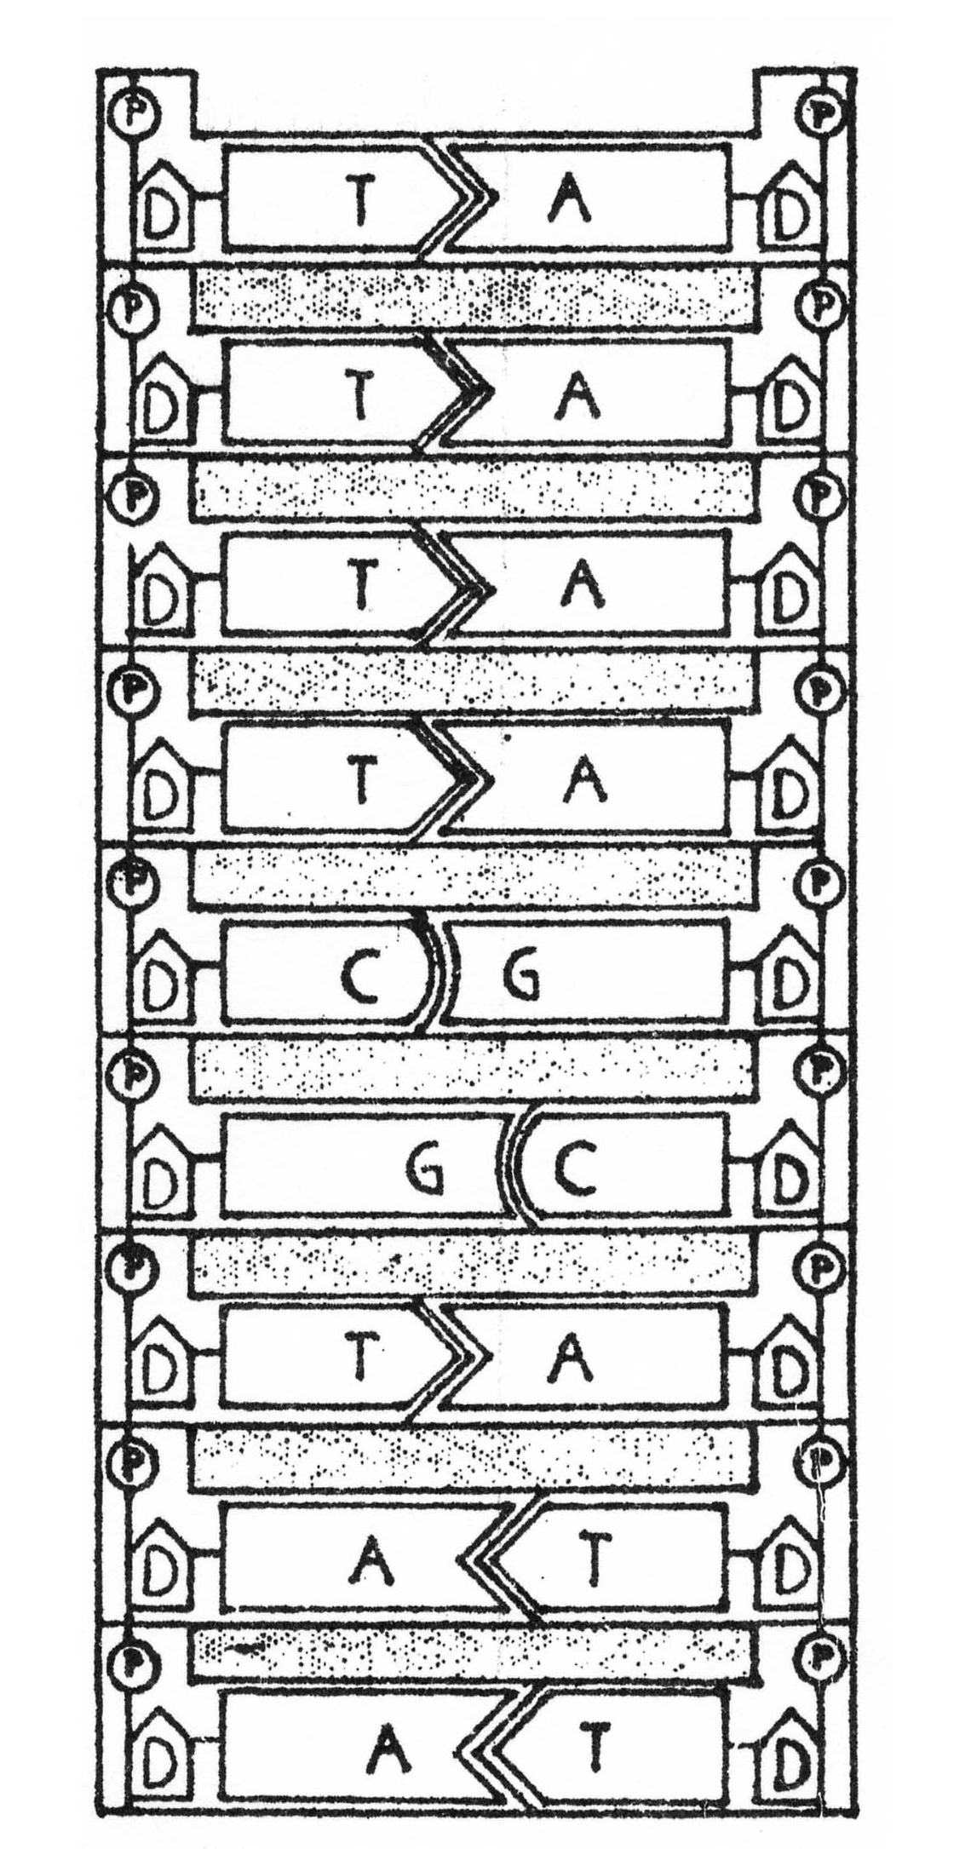

Instructions: Practice base pairing.
ATG CCG ACG TAC GGC GTC AAG TAG
___ ___ ____ ___ ____ ___ ____ ___
DNA Function
DNA contains the _______________________ to make you.
“ ____________________” = all of your DNA
“____________________” = one set of instructions within your DNA

“The Animated Genome”Video
Instructions: Watch the video and answer the following questions. The video time codes are noted, you may have to pause the video as you complete the information:
:04 Inside each cell is a code of instructions for life.
This is your _________________.
When unfolded, it is ______ feet long!
All cells have the same genome, true or false? (circle one)
:23 What is your genome made of? _______________________________.
It is the parts list and ____________________ ____________________ for life.
What are the names of the 4 chemicals used by your genome?
_________________ ___________________ __________________ __________________
:58 How many letters form words in your genome? _______
What does each word code for? ___________________________________________________
What is each sentence in your genome called? _______________________
What is working hard so you may breathe, move and think? ____________________
2:04 What is the fancy word for all of your DNA? _______________________
Can the way you live influence the way your genome works? yes or no (circle one)
2:57 DNA has ____________ complimentary strands.
_______ always matches _______ and ________ always matches _________
When cells divide, the strands _________________
3:22 What repairs matching errors? ________________
What is the cause of many cancers? _______________________________
During cell division, the genome gets condensed into groupings called ________________________
You get 23 chromosomes from your mother and father.
3:55 What happens if you get a faulty chromosome from one parent?
_________________________________________________________
What did the video mean by “that’s why you don’t marry your sister”
_____________________________________________________________________________________
What percent of your genome is identical to the person next to you? __________
What percent of your genome is identical to a mouse? __________
What percent of your genome is identical to a fly? ___________
What percent of your genome is identical to a banana? _________end of video.

DNA Replication
_________ ________________________ takes place during ______________________ of the cell cycle.
The purpose of DNA Replication is to ___________________ the DNA that was divided during anaphase.
DNA replication takes place in the _______________________ of the cell.
Enzymes
_____________________ play a crucial roll in DNA replication.
DNA __________________ separates the strands of DNA by breaking the bonds between the bases.
To remember: Think of a ____________________ ____________ flying in and splitting the DNA strand!
DNA _________________ builds bond between the free floating nucleotides and the DNA strand.
_________________ binds the base pairs.
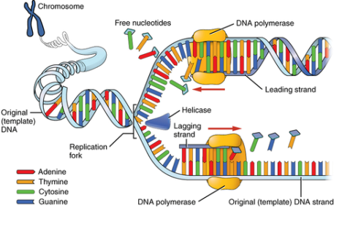

Protein Synthesis and RNA Transcription
Objectives
Explain that DNA must be transcribed into a message the ribosome can read
Explain that thymine must be replaced with uracil so the ribosome can read the genetic code
Explain that transcription takes place in the nucleus
Explain that the enzyme “RNA polymerase” synthesizes the mRNA strand from free floating nucleotides
Know that mRNA is “Messenger RNA”
Know that mRNA will take the DNA code, or message to the ribosome
Know the base pairing rules of transcription: G & C pair; A & U pair

NOTES
Two Steps in Protein Synthesis:
1.
2.
mRNA
mRNA =
RNA =
The structure of RNA is similar to DNA with three important differences:
- ____________________________ (not double helix)
- ____________________________ instead of thymine
- The sugar is ______________________ instead of deoxyribose
Transcription of DNA to mRNA:
Transcription takes place during _________________________ phase of the cell cycle.
Purpose: Transcribe DNA into a ________________________ the ______________________ can read.
_________________________the message to the ribosome.
THINK: ____________________________________________________________________________
Transcription to mRNA occurs inside the _________________________ of the cell.
Transcription to mRNA is similar to __________ ____________________________.
Thymine is replaced with __________________________.
___________________ pair; _______________________ pair.
________ _____________________ is the enzyme that synthesizes mRNA
Transcription to mRNA Summary
Ribosomes read the genetic code in DNA, however ribosomes can’t read the “Thymine” base, so Thymine is replaced with “Uracil”in a strand of mRNA. Then the message is taken from the nucleus to the ribosome by mRNA.

Protein Synthesis Model Rubric:
Illustrate Protein Synthesis  10 Points for Each Item, 170 points total | Points
1. Label Nucleus
2. Label Ribosome
3. DNA strand
4. Replicated DNA Strand
5. DNA Polymerase synthesizing DNA strand
6. Label DNA Replication
7. DNA Helicase degrading DNA strand
8. DNA Ligase sticking base pairs together
9. Transcribed mRNA Strand
10. RNA polymerase synthesizing mRNA strand
11. Label Transcription
12. mRNA exiting nucleus
13. mRNA surrounded by Ribosome subunits
14. tRNA anti-codons attached to mRNA codons
15. Amino acids forming polypeptide chain
16. Label translation
17. Protein
Total Points:

Leave Blank for Back of Project
Leave Blank for Back of Project
Protein Synthesis and RNA Translation
Objectives
Explain that mRNA strands leave the nucleus and travels through the cytoplasm to the ribosome.
Explain that Translation occurs in the cytoplasm between ribosome subunits
Explain that the genetic code carried by mRNA contains the instructions for making proteins
Explain that amino acids are assembled into proteins based on the genetic code on the mRNA strand
Explain that mRNA is read in triplicates called “codons”
Explain that each codon codes for a specific amino acid
Explain there are 20 amino acids that make up all living things
Explain that the anti-codon on tRNA matches codons on the mRNA strand
Demonstrate translation of mRNA strand into a protein
Explain that tRNA is “Transfer RNA”
Explain that tRNA transfers amino acids to the ribosome sub units to be assembled into proteins
NOTES
Translation to Protein
Takes place during the _______ phase of Interphase.
Purpose: ________________ the message delivered by the mRNA strand
To make a ____________________from ________________ __________________.
Think: _______________________________________________________________________________.
Once the mRNA strand has been transcribed, it travels out of the nucleusthrough the
_____________________ to the _________________________.
Translation occurs in the _______________________________.
Ribosome subunits read the mRNA strand and signal _____________ to transfer
_______________ _______________ to the active site.
tRNA = _________________________________________
Triplicates in the mRNA strand, called ________________ code for specific ___________ ___________.

tRNA ____________________________ pair with the codons.
mRNA base pairing rules apply: _______&_______ pair; _______ & _______ pair.
_____________ ________________ transferred by tRNA bond forming a protein.
_____________ & _______________ codons mark the beginning and end of each gene.
Protein Synthesis Practice:
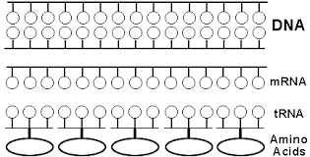

Codon Table:
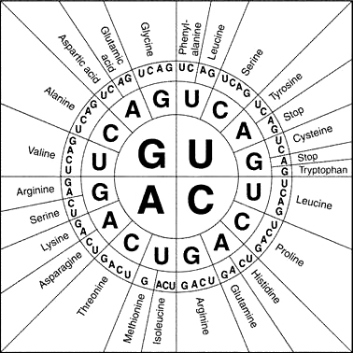

Genetic Mutations
Objectives
Explain that a mutation is a change in an organism’s DNA
Explain that mutations can be caused by errors in DNA replication
Explain that point shift mutations occurs when one nucleotide is improperly replicated
Explain that DNA polymerase usually corrects point shift mutations, but not always
Explain that frameshift mutations occur when a nucleotide is added or deleted causing the entire strand to shift
Explain that environmental factors causing DNA mutations are called “mutagens”
Give three examples of mutagens
Explain that mutagens affecting cell division may cause cancer
Explain that mutations to a gamete can be passed on to offspring
Explain that mutations to somatic cells will not be passed on to offspring
NOTES:
Genetic mutations are simply ______________________ in an organisms DNA.
Sometimes they are ______________________________
Sometimes they are ______________________________
Causes of Mutations
- Errors in __________ ____________________________
- Errors during ________________ ____________________
- ___________________ factors, these are called ______________________
Heritable Mutations
- Mutations to the _______________ can _____ be inherited
- Mutations to the _______________ can be inherited

Types of Mutations
Point Mutations
- One base is replaced with another
- Usually occurs during DNA replication
- Usually corrected by DNA polymerase
- Might even code for the same amino acid and go unnoticed

Instructions:
Circle the point mutation below. What base should have been in its place? __________
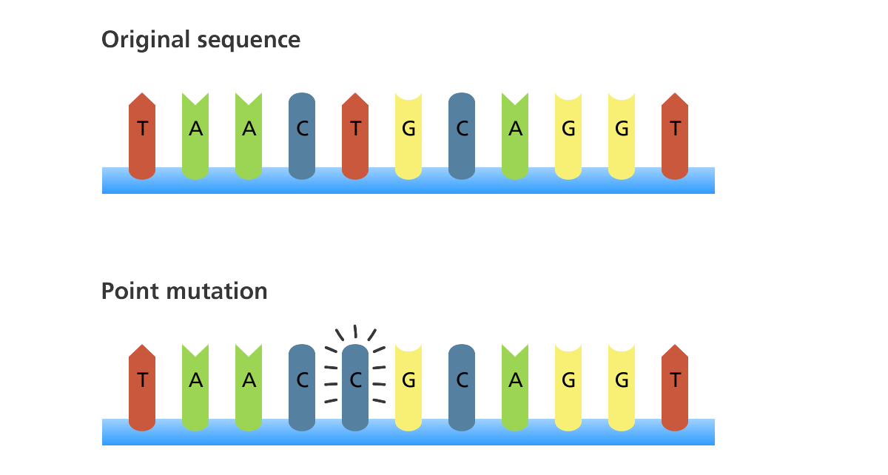

Substitution
- Similar to point mutation, however it may affect more than one base
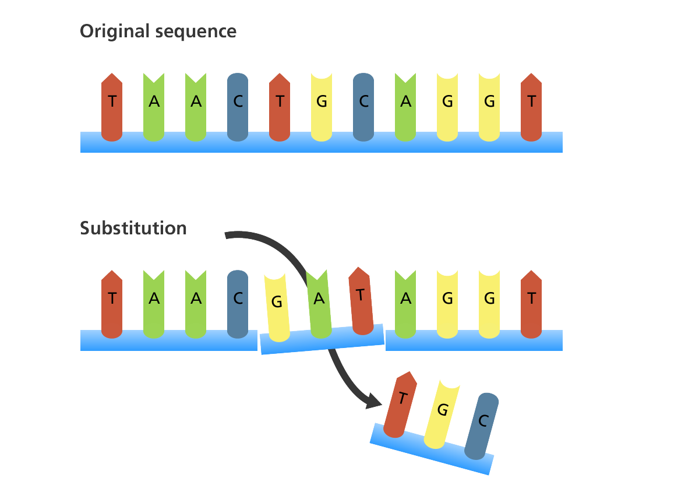

Frame Shift Mutations
- Base is inserted or deleted causing a shift in strand of DNA.
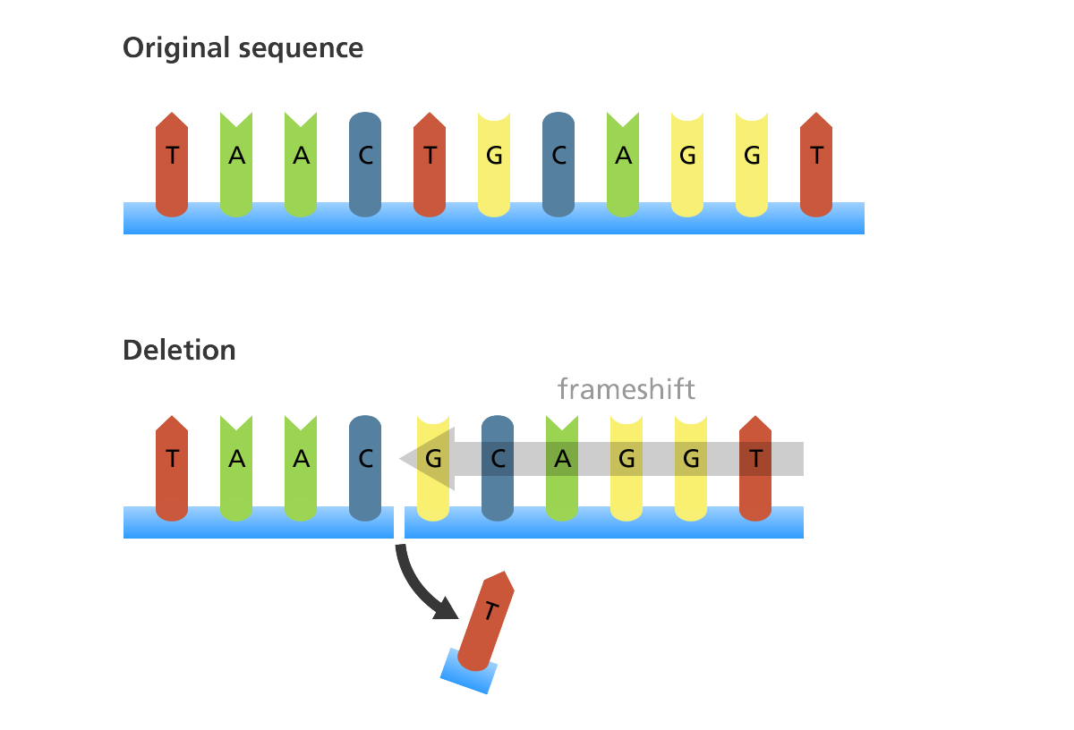
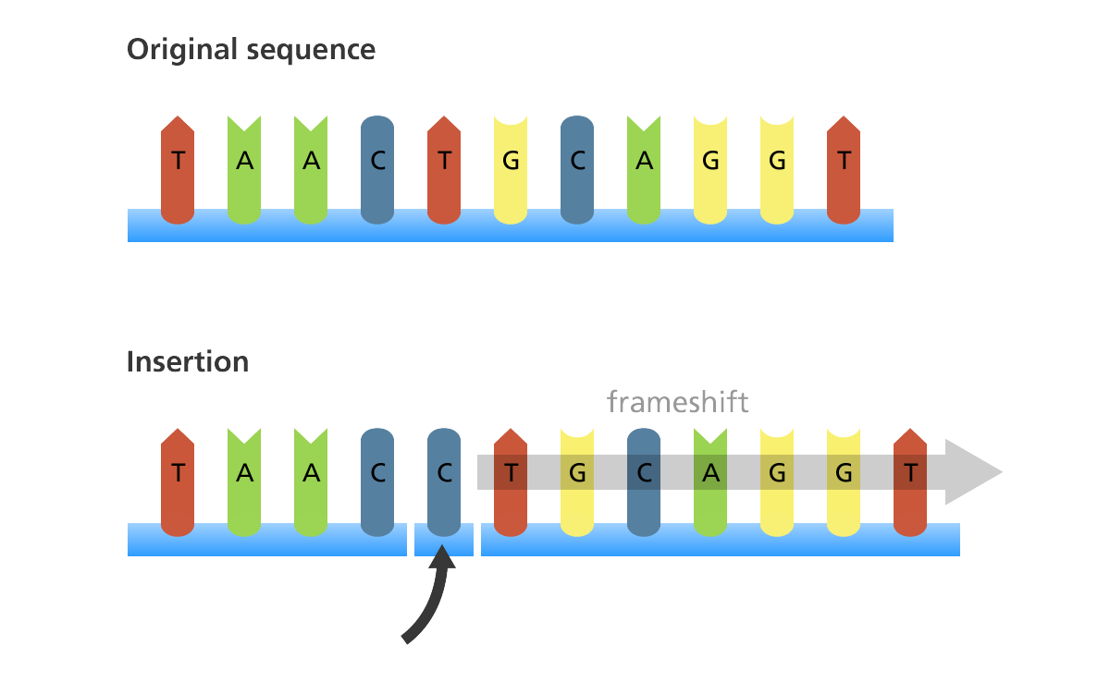
- Serious mutation that changes the resulting protein

Inversion
- Segment of DNA inverts 180 degrees
- This type of mutation happens during crossing over in meiosis
- Changes the resulting protein

Instructions:
Circle the inverted segment of DNA.
What should the order of bases have been? ______________________________

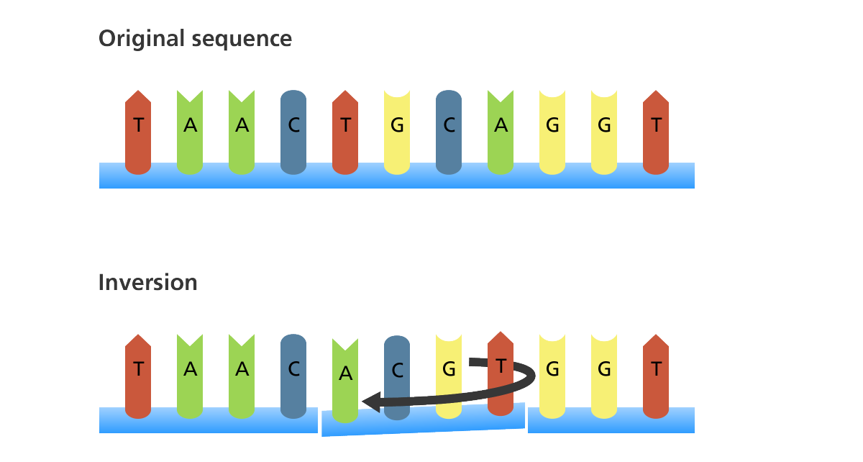
Bee Lab

Lab is worth 100 points

Instructions:
Work with a partner to create bees based on the instructions on the lab sheet. Some of your bees will be a healthy bee. Others will have a genetic mutation. Not all students have a bee with the same mutation, so your bee may not look the same your neighbor’s.

Post Lab Questions:

What type of mutation does your bee have, point or frame shift?

How did it affect the physical characteristics of your bee?

Is this mutation positive, negative or neutral?

Will this mutation affect the overall health of your bee?

