Name__________________________________________________________Lab_____Block_____

Cellular Reproduction Unit
- Chromosome Structure and Function
- Development of Multicellular Organisms
- Differentiation, Germ Layers & Cellular Organization
- The Cell Cycle and Mitosis
- Meiosis

Chromosome Structure and Function
Objectives
Model the anatomy of a chromosome understanding chromosomes are made of tightly wrapped bundles of DNA
Explain the function of a chromosome
Explain humans have 46 chromosomes, 23 from each parent
Illustrate
Draw a chromosome. Label the parts.

NOTES
Chromosomes are located in the _____________ of cells.

Chromosomes are made of ___________ wrapped
around ______________ called histones.

Function of a chromosome: ______________ ________
before splitting during anaphase of the cell cycle.

Humans have ________ chromosomes in every cell in
their body, except the egg and sperm which have 23.

Humans get _______ chromosomes from each parent.

Chromosomes are charted on a ___________________ .

Homologous means _____________________________.

So, humans have _____ ____________ of chromosomes.

Fun Fact: Not all organisms have 46 chromosomes!

Dogs have _______ pairs, or _________ chromosomes.
Fruit flies have ______ pairs or ________ chromosomes.
Horses have ______ pairs, or ________ chromosomes.

Digital Activity - Google Classroom
Open the “Cellular Reproduction” digital assignment. Complete the “Karyotype” and “Cells to Systems” activities.
Chromosomes and Traits Model
Instructions:
- Cut out chromosomes, there are three from the maternal parent and three from the paternal parent.
- Number the bands on the large chromosome pair 1 - 12.
- Number the bands on the medium chromosome pair 1 - 7.
- If you are a female, don’t do anything to the small pair of chromosomes.
- If you are a male, fold the bottom right arm of your chromosome up so it resembles a “y” and color the first band of your “y” chromosome blue.
- Complete the table below with the allele you received from each parent. Note: If you display a recessive trait, you would have inherited a recessive allele from each parent. If you display a dominant trait you would have received a dominant allele from one parent, and could have received a dominant or recessive from the other. Please do some inquiry to make your table as accurate as possible.
- Using the data from the table below, fill in each band of the chromosomes with the appropriate allele.

Note: traits are complex, some have multiple alleles and many genes can be turned on and off due to environmental factors. This activity is meant to be a very simplistic model.

Large Pair of Homologous Chromosomes
Band | Trait |  | Dominant | Recessive |  | Allele from Mom | Allele from Dad
1 | hair type |  | straight | curly or wavy
2 | hair color |  | brown | all other (red recessive to all) |  | If recessive, what color? | If recessive, what color?
3 | eye color |  | brown | all other |  | If recessive, what color? | If recessive, what color?
4 | height |  | normal | tall or short
5 | freckles |  | none | freckles
6 | full lips |  | full lips | thin lips
7 | widow’s peak |  | widow’s peak | smooth hairline
8 | earlobes |  | free | attached
9 | clef chin |  | clef | no clef
10 | dimples |  | no dimples | dimples
11 | hand folding |  | left over right | right over left
12 | skin color |  | incomplete | incomplete
Medium Pair of Homologous Chromosomes
Band |  | Trait | Dominant |  | Recessive | Allele from Mom | Allele from Dad
1 |  | handedness | right |  | left
2 |  | vision | normal |  | glasses
3 |  | heart disease | normal heart |  | heart disease
4 |  | diabetes | normal |  | diabetic
5 |  | athleticism | normal |  | very athletic
6 |  | musicality | normal |  | musically gifted
7 |  | disposition | extroversion |  | introversion
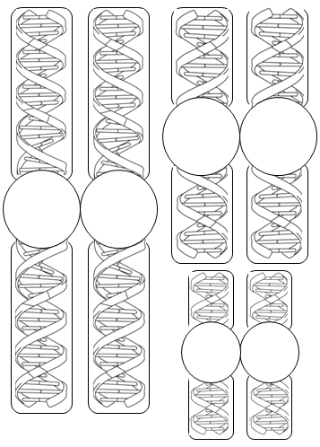
Your Chromosome from Maternal Parent

Your Chromosome from Maternal Parent

Your Chromosome from Maternal Parent

Your Chromosome from Maternal Parent

Your Chromosome from Maternal Parent

Your Chromosome from Maternal Parent

____________________________________________________________________________________________________________________________________________________________________________________________________________________________________________________________________________________________________________________________________________________________________________________________________________________________________________________________________________________
____________________________________________________________________________________________________________________________________________________________________________________________________________________________________________________________________________________________________________________________________________________________________________________________________________________________________________________________________________________
Your Chromosome from Paternal Parent

Your Chromosome from Paternal Parent

Your Chromosome from Paternal Parent

Your Chromosome from Paternal Parent

Your Chromosome from Paternal Parent

Your Chromosome from Paternal Parent

Pocket
Instructions: Make a pocket by folding the bottom third of this page up and taping the sides. Store your chromosomes here to be used during the meiosis lesson.

--------------------------------------------------------------------------------------------------------------------------------------------------------

Pocket Page

Development of Multicellular Organisms
Objectives
Model cellular reproduction from zygote to blastula
Explain why embryotic stem cells must be extracted at the blastula stage
_____________________________________________________________________________________
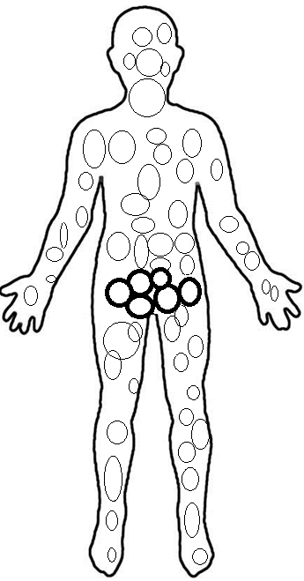
Notes

Humans begin as a single cell that ______________________ until an organism is formed. Because we are made of many cells, we are _____________________ organisms.

Human cells can be divided into two categories:.
_________________ and __________________

Gametes
Gametes are the sex cells, or the ____________ and ___________ cells. Egg cells are also called __________________ or __________________.

Tip to Remember: The sperm and egg play a _______________ and they mate! “Game-Mates”

Every gamete has ___________ chromosomes.

Gametes are _____________________ cells. Haploid means “________________” or having unpaired chromosomes.

Somatic Cells
Every cell that is not a gamete is a __________________ cell.

Every somatic cell has _______ chromosomes, _______ from each parent, so there are 23 pairs.

Somatic cells are _______________ cells. Diploid means containing __________ of chromosomes.

Illustrate
Illustrate the number of chromosomes.
Label gametes or haploid cells(in bold) with 23
Label somatic or diploid cells with 46

Development of Multicellular Organisms Instructions: Label gametes, zygote, morula, blastula and gastrula. Label the stage at which differentiation occurs, and pluripotent or stem cells. Label layers of gastrula. Label the gametes with 23 and a few cells in every cluster of somatic cells with 46 to indicate the number of chromosomes in each cell.

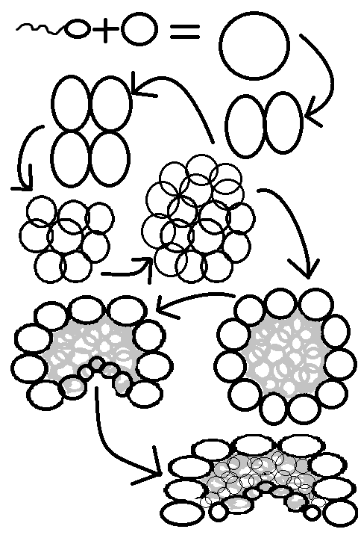
Differentiation, Germ Layers
& Cellular Organization
Objectives
Explain the tissues that arise from the endoderm, mesoderm and ectoderm (germ layers).
Predict what would happen if a genetic mutation specific germ layers.
Order the levels of cell organization from organelle to organ system.
_____________________________________________________________________________________

Germ Layers of the Gastrula

The gastrula divides into three layers, called _______________________________.

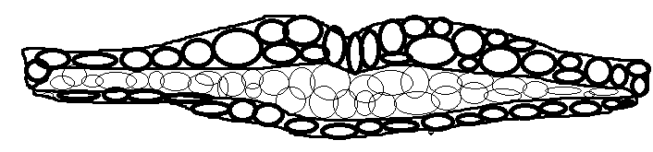

Cells to Systems
Multicellular organisms are organized as follows

____________________ group to make cells
____________________ group to make tissues
____________________ group to make organs
____________________ group to make organ systems
____________________ group to make organisms
____________________

Digital Activity
Finish the “Cellular Reproduction” digital assignment in Google Classroom.

Critical Thinking Questions
Which series shows the different levels of cellular organization in order from the least complex to the most complex?
A. cell, tissue, organ, organ system, organism
B. tissue, cell, organ, organism, organ system
C. cell, organism, tissue, organ, organ system

What is cell differentiation?
A. The process of a cell turning into an organ
B. The process of a cell multiplying
C. The process of a stem cell becoming specialized

Which describes a stem cell?
A. specialized
B. gamete
c. pluripotent

Give examples of what a stem cell might differentiate into:
A. heart, lung, stomach, skin
B. skin cell, muscle cell, erythrocyte, nerve cell
C. mitochondria, lysosome, ribosome

Which series lists the structures in order of their formation during embryonic development?
A. zygote, blastula, mesoderm layer
B. gastrula, ectoderm layer, zygote
C. zygote, endoderm layer, blastula

What embryonic tissue layer gives rise to the small intestine?
A. ectoderm
B. endoderm
C. mesoderm

If a mutation occurred in one of the mesoderm cells of a developing embryo which tissues or organs might be affected?
A. muscles, heart, reproductive organs
B. lungs, bladder, stomach
C. eyes, brain, spinal cord

The Cell Cycle and Mitosis
Objectives
Describe and illustrate each phase of the cell cycle
Describe the length of interphase as to be compared with mitosis
Describe what happens during interphase stating that DNA is being replicated
_____________________________________________________________________________________
Notes
Somatic cells______________________ in a continuous _________________ _________________.

Two main phases: __________________________ and _____________________________________.

Mitosis
Mitosis is the __________________________ of a parent cell, into two ___________________________________.

Remember: “Mi - _______________ - sis” makes two identical daughter cells, like sisters!

What pneumonic device will remind you of the order? __________ ___________ ___________ ___________

Interphase
________________ of the cell’s lifetime is spent in Interphase. During this phase cells ______________________, grow, develop and carry out their normal functions.
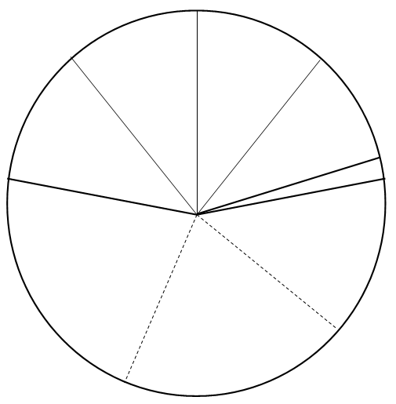
Cytokinesis
The cytoplasm splits resulting in two identical cells called “daughter cells”.

Telophase
Nuclear envelope forms around each group of chromosomes.

Interphase
- G1: Cell grows; checkpoint for errors in DNA
- S Phase: Chromosomes unwind and replicate the half of the chromosome that was split apart during anaphase.
- G2: Cell grows; check point for errors in DNA

Anaphase
Spindle fibers pull chromosomes apart toward the centrioles.

Metaphase
Chromosomes line up in the middle. Spindle fibers form from centrioles to chromosomes.

Prophase
Chromatin condenses into chromosomes.
Centrioles move to opposite ends.

Leave this page blank since previous page will be cut.
The Cell Cycle

Digital Lab: Online Onion Root Lab

Instructions: Complete the online onion root lab. The data table for the lab is included in your work packet. Enter the data you collect in the data table provided in your work packet. Read every screen, follow the instructions on every screen. Click “next” at the bottom of each screen until the activity is complete. You do NOT have to click the “vocabulary” links at the bottom of each screen.

Online Onion Root Lab: http://www.biology.arizona.edu/cell_bio/activities/cell_cycle/cell_cycle.html

Onion Root Tip Lab Data

What phase had the largest number of cells?

Why were there more cells in that phase?
Meiosis
Objectives
- Describe and model the process of meiosis
- Explain the relationship between the genetic make-up of the parent cell and the daughter cells
- Explain how crossing-over, independent assortment, and random fertilization result in offspring that are genetically different from the parents.
____________________________________________________________________________________

NOTES
Meiosis is cell division resulting in ________________________ (sperm and egg cells).

Meiosis _____________________the number of chromosomes to 23.

Meiosis results in four genetically ______________________ cells.

They are called ______________ granddaughter cells

Haploid means having “ __________ “ the chromosomes, or having a “ ________________ _______ “ of chromosomes.

Remember: “__________-iosis” made the cells that made me!

Genetic Variation

Meiosis results in genetic variation within a species for three important reasons:

1. ________________________ of genetic material during Prophase 1 of Meiosis

2. _______________________________________ of genetic material during Metaphase 1 of Meiosis

3. ________________________ fertilization

- Females are born with about ______________________ eggs. Most die before puberty when we are left with about ______________________

- Males will make about __________________________ cells over a lifetime.

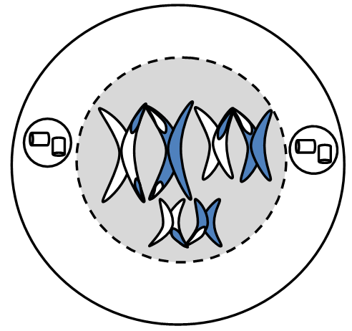
Meiosis - Meiosis 1
Prophase I
46 Homologous chromosomes pair up. Homologous chromosomes cross over each other and exchange DNA. This is called “crossing over” crossing over results in genetic variation. Note: crossing over is sometimes called “recombination”. Nuclear envelope dissipates. The actual event of allele exchange is a rare event and is known as recombination

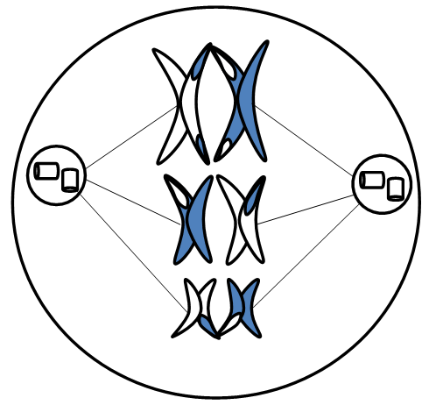
Metaphase I
Homologous pairs line up along the equator of the nucleus. It doesn’t matter which side of the equator the chromosome from each parent are on. This is called “Independent Assortment”. Independent assortment results in genetic variation. Spindle fibers attach the centrioles to the centromeres of the chromosomes.

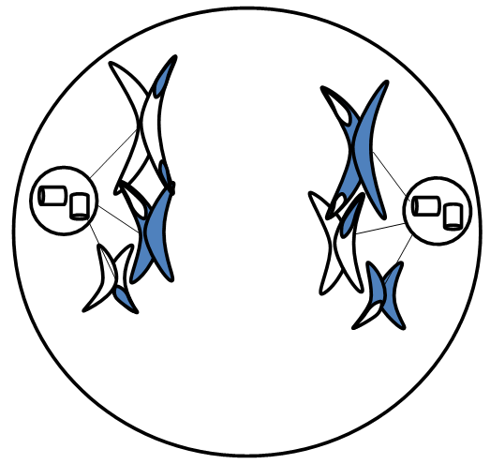
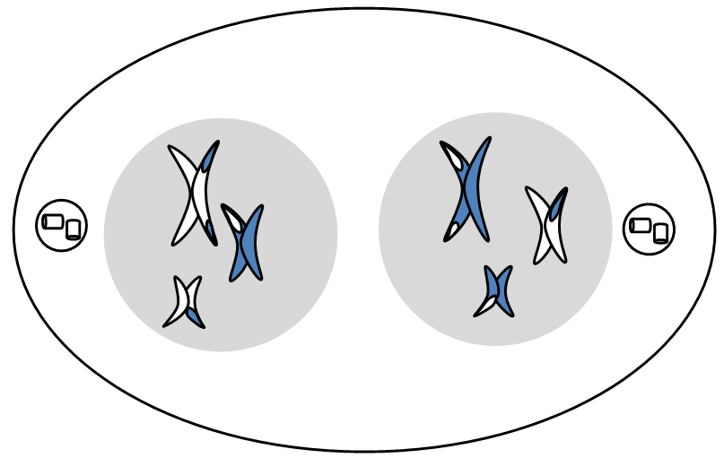
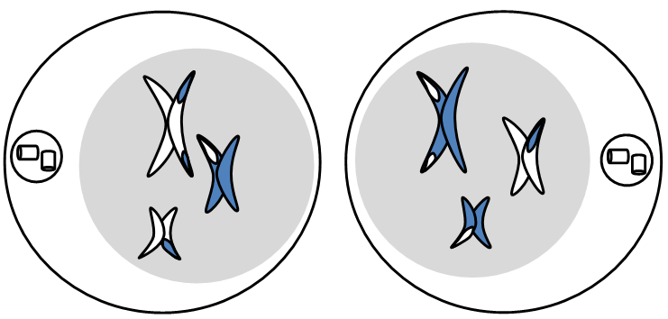
Telophase I
Nuclear envelopes form around chromosomes at polar ends of the cell.

Cytokinesis
Cytokinesis occurs resulting in 2 genetically different cells with 23 chromosomes.

Anaphase I
Spindle fibers pull the homologous chromosomes apart. Pulling the entire chromosome will reduce the number of chromosomes in each cell to half, 23 instead of 46, at the end of Meiosis 1.

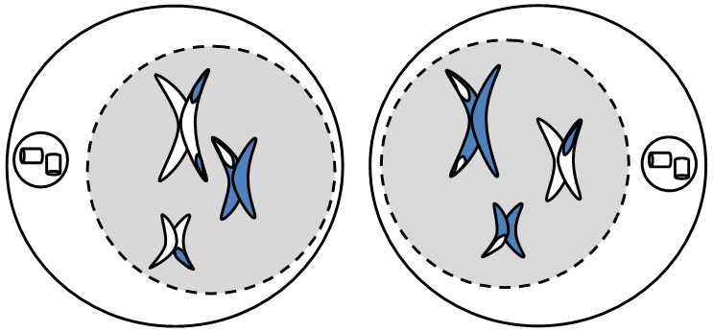
Meiosis 2
Prophase II
Each cell begins with 23 chromosomes.
Centrioles move to polar ends of cells.
Nuclear envelopes dissipate

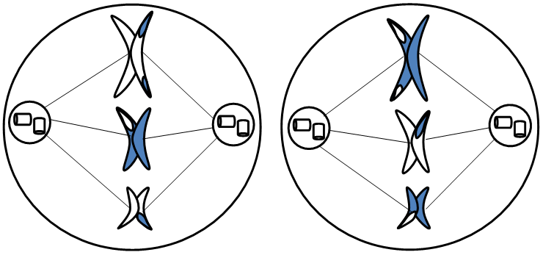
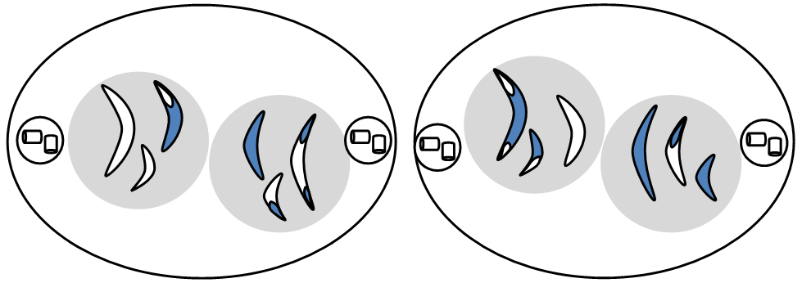
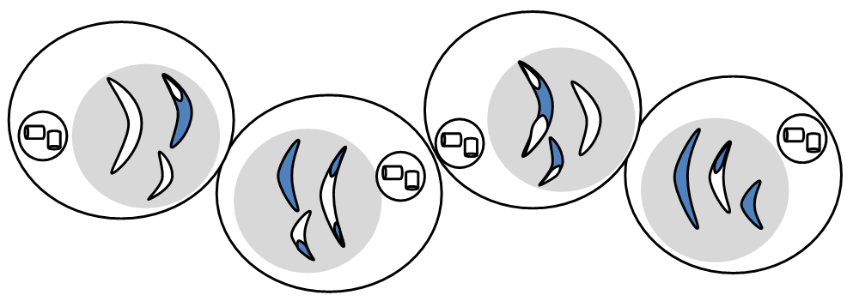
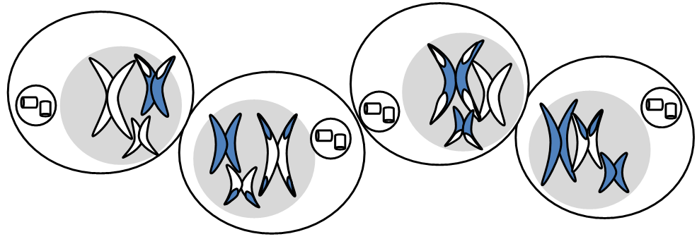
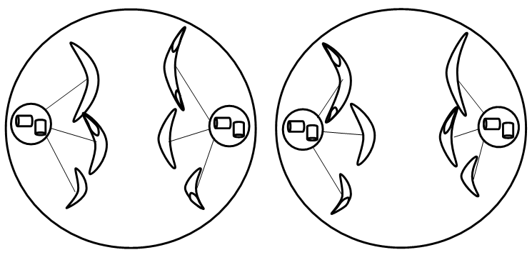
Interphase
DNA replicates and cells grow
Cytokinesis
Cytokinesis occurs resulting in 4 genetically different cells.

Anaphase II
Spindle fibers pull chromosomes apart (rip in half, just like mitosis).

Telophase II
Nuclear envelopes form around each cell.

Metaphase II
Chromosomes line up in the middle of each cell. Spindle fibers attach centrioles to chromosomes

Baby Shower Day!

Large Pair of Homologous Chromosomes
Band | Trait | Dominant | Recessive | Allele from You | Allele  from Mate | Baby’s Trait
1 | hair type | straight | curly or wavy
2 | hair color | brown | all other
3 | eye color | brown | all other
4 | height | normal | tall or short
5 | freckles | none | freckles
6 | full lips | full lips | thin lips
7 | widow’s peak | widow’s peak | smooth hairline
8 | earlobes | free | attached
9 | clef chin | clef | no clef
10 | dimples | no dimples | dimples
11 | hand folding | left over right | right over left
12 | skin color | incomplete | incomplete
Medium Pair of Homologous Chromosomes
Band | Trait | Dominant | Recessive | Allele from You | Allele from Mate | Baby’s Trait
1 | handedness | right | left
2 | vision | normal | glasses
3 | heart disease | normal heart | heart disease
4 | diabetes | normal | diabetic
5 | athleticism | normal | very athletic
6 | musicality | normal | musically gifted
7 | disposition | extroversion | introversion
Small Pair of Homologous Chromosomes
The 23rd pair of chromosomes determines whether we are male or female. Females have two “X” chromosomes so they always pass on an “X”. Males have an “X” and a “Y” chromosome, so their gamete determines the sex of their offspring. If your baby is “XX” it is a girl. If your baby is “XY” it is a boy. |  |  |  |  |  | Boy or Girl?

Baby Model Instructions
Congratulations! Your baby arrived today. Your job is to make a model representing your baby’s 20 traits: 12 from your large chromosome, 7 from your medium chromosome, and 1 from your small chromosome (boy or girl). Some traits are more difficult than others to illustrate, because they are something the eye can’t see, use your imagination to illustrate them on your model.

Grading
Each of the 20 traits is worth 5 points for a total of 100 points. Use the chromosome and trait model worksheet as a check list for your model. Turn in the chromosome and trait model worksheet with your baby when the baby model is complete.

Materials
Please use construction paper, glue and tape (please use tape only if it is needed for something glue can’t do since my tape supply is running low). There are templates available to help you with cut-outs and to be used as a guide for size.

Critical Thinking Questions
Imagine that sex cells divided by mitosis instead of meiosis. What would the result be?
A. The formation of two identical cells
B. The new individual would be identical to only one parent
C. Fertilization would cause crossing over and recombination of genes
D. Cells of the new individual would have double the necessary number of chromosomes

Which statement explains why half of an individual’s DNA sequence comes from each parent?
A. A cell from one parent undergoes meiosis producing offspring cells that have both parent’s DNA.
B. A cell from one parent undergoes mitotic cell division, producing offspring cells that have only half of that parent’s DNA.
C. Cells in the parents undergo meiosis, producing haploid gametes that meet up during fertilization to produce a diploid individual.

Meiosis is the form of cell division that produces gametes. Which of the following statements correctly describes gametes?
A. In spermatogenesis, eight sperm cells are produced
B. Eggs are diploid and, when fertilized, give rise to haploid cells
C. In the formation of eggs, four identical haploid cells are produced
D. In oogenesis, the cytoplasm divides unequally, producing an ovum and three smaller polar bodies

Cells and the organisms they make up reproduce through cell division. Some organisms reproduce through mitosis, while others reproduce through meiosis and fertilization. What advantage does meiosis give to organisms that reproduce sexually?
A. Meiosis ensures that offspring inherit genes from their parents.
B. Meiosis ensures that offspring will not inherit any genetic disorders.
C. Meiosis ensures that offspring are genetically different from their parents.

Crossing over contributes to the recombination of genetic material in offspring. When does crossing over happen in meiosis?
A. Prophase I
B. Prophase II
C. Metaphase I
D. Metaphase II

