Name _______________________________________________ Lab _______ Block ________
Interdependence Unit
- Ecosystems
- Ecological Relationships
- Matter Cycles
- Populations and Carrying Capacity
- Human Impact

Ecosystems
Objectives
Explain that the amount of life an environment can support is limited by the available energy, water, oxygen, and minerals, and by the ability of ecosystems to recycle the remains of dead organisms.

Describe the consequences of introducing a non-native species into an ecosystem and identify the impact it may have on an ecosystem

Lecture Notes:
Ecology:

Biosphere:

Biome:

Ecosystem:

Biotic Factors:

Abiotic Factors:

Community:
Population:

Organism:

Habitat:

Niche:

Biodiversity:

Keystone Species:
Google Classroom Assignment:
______ Keystone Species Google Slides Project

Ecosystem Project
Instructions:
1. Read about the Biomes at here: http://kids.nceas.ucsb.edu/biomes/

2. Choose one that interests you.

3. Draw an ecosystem from the biome you have chosen. Illustrate enough biotic and abiotic factors that you can answer the following questions about your ecosystem:

What biosphere is it on?

What biome is it in?

What is the climate like in your ecosystem?

List the biotic Factors:

List the abiotic Factors:

Give an example of a community in your ecosystem:

Give an example of a population in your ecosystem:

Tell about the habitat that belongs to one of your organisms:

Tell about the niche of one of your organisms:

Is there biodiversity in your ecosystem?

Give an example of a keystone species in your ecosystem:

Explain the chain of events that would occur if your keystone became extinct:

Introduce an invasive species to your ecosystem and make up a short storyline about how it affects your ecosystem:

Ecological Relationships
Competition:

Example:

Predation:

Example:

Mutualism:

Example:

Commensalism:

Example:

Amensalism:

Example:

Parasitism:

Example:
Matter and Nutrient Cycles
Objectives
Explain that the amount of life an environment can support is limited by the available energy, water, oxygen, and minerals, and by the ability of ecosystems to recycle the remains of dead organisms.

Living things are made of four compounds:

Lipids broken down into __________________________.

Proteins broken down into _______________________.

Carbohydrates broken down into __________________.

Nucleic acids are broken down into ____________________________ that build our DNA and RNA.

When all of these compounds are broken down into their simplest form of matter they are made of the same for elements: carbon, hydrogen, nitrogen, oxygen, phosphorous and sulfur.

Remember: “CHNOPS”

Carbon is found in the all, and is the most abundant.

Which element is the most abundant in living things? _________________________.

These elements, or matter, are constantly cycled through the biosphere in cycles called. Matter never destroyed or created, instead it is continually recycled in different forms. We are going to explore four of these cycles: the water cycle, carbon cycle, nitrogen cycle and phosphorous cycle.

Is matter every destroyed or created? __________

Transpiration Lab
Fill beakers ½ way with water.
Add food coloring.
Place nappa cabbage leaf in beaker with colored water.

Make a hypothesis about how the water will interact with the cabbage leaf:

___________________________________________________________________________________

___________________________________________________________________________________

Water Cycle
Water is constantly moves between the oceans, the atmosphere, and the land. It can be inside organisms or outside of them. Water molecules usually enter the atmosphere by evaporating from bodies of water or from plant leaves. When it evaporates, water becomes a gas called water vapor.

Modeling the Water Cycle
In cooling air, the vapor condenses into tiny droplets that form clouds, this called condensation. When the droplets become large enough, they fall to the Earth’s surface as precipitation. This can be in the form of rain, snow, sleet or hail. Precipitation that falls to the ground becomesrunoff, flowing along the surface of land into a river or stream. Precipitation can also be absorbed into the ground, becoming groundwater, this is called absorption. Some groundwater enters plants through their roots and then returns to the atmosphere from the stomata in their leaves, this is called transpiration.Some ground water or flows through the soil where it is filtered, which is called percolation, and eventually flowsthrough the ground into bodies of water such as the ocean. When the sun warms reservoirs of water, the water becomes vapor and returns the atmosphere, this is called evaporation.

Instructions: Show the flow of water in the diagram below. Label all parts of the water cycle that are shown in bold above.

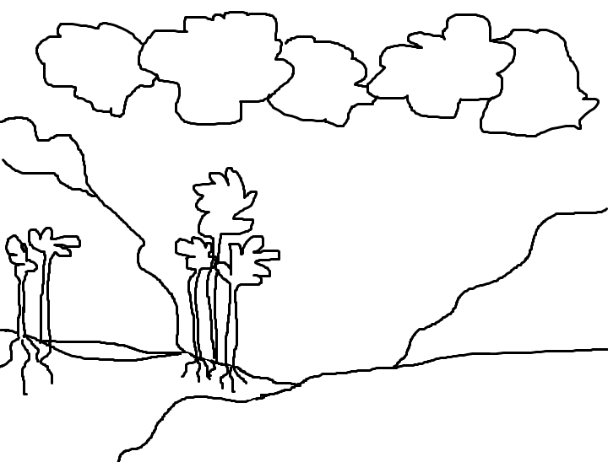

Carbon Cycle
Carbon is found in several large reservoirs in the biosphere. It is found as carbon dioxide gas in the atmosphere. It is found as dissolved carbon dioxide in the oceans. It is found as calcium carbonate in organisms, rocks and soil. It is also found deep underground in sinks that store fossil fuels such as coal, oil and natural gas.

Burning fossil fuels releases carbon dioxide into the atmosphere, and so do forest fires. Consumers exhale carbon dioxide as a waste product from cellular respiration both on land and in the water. Dissolved carbon dioxide returns to the atmosphere when water evaporates. When organisms decompose, the carbon carbonate in their bodies is absorbed into the soil. Producers on the land take in carbon dioxide from the atmosphere to be used in photosynthesis. Producers in waterways also take in carbon dioxide to be used in photosynthesis. Carbon dioxide dissolves in rain water where it is carried back to the land and waterways.

Instructions: Show the cycling of carbon in the diagram below illustrating all items described in bold.

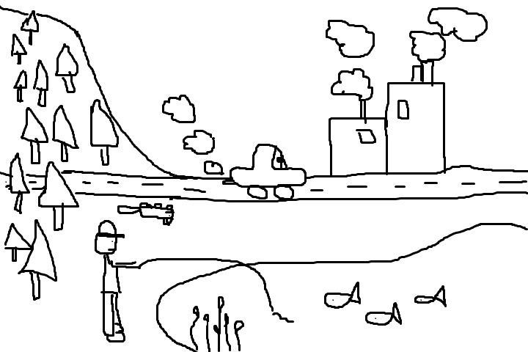

Nitrogen Cycle
Nitrogen is crucial to all life on Earth. It is needed to make amino acids, the building blocks of proteins, and nucleic acids, the building blocks of DNA, in all living things. Seventy-eight percent of the world’s atmosphere consists of nitrogen gas, however, it is not in a form that can be used by living organisms because the bonds of the nitrogen gas molecule are so strong. Instead, organisms use the form of nitrogen, called nitrates. The process of converting nitrogen gas into nitrates is called nitrogen fixation (remember, it has to be “fixed” before it can be used). Most nitrogen fixation happens in the soil where bacteria break down or “fix” the nitrogen through the fixation process. Some plants, called legumes, have nodules in their roots where bacteria live. The bacteria in the nodules of legumes also convert nitrogen into its usable state through fixation.

Nitrogen enters the food chain through the roots of plants. Plants absorb nitrates. Consumers eat plants and when they do, they absorb the nitrogen. Afterwards, consumers excrete what has not been used into the soil. Once again, bacteria break down the waste so it can be recycled.

Constructed Response:

Grading
2 points = Entire response is written in complete sentences and the questions have been answered.
1 point = Response is not written in complete sentences, but questions have been answered.
0 point = Response is not written in complete sentences, questions have not been answered.

Question
If decomposers were wiped out of the biosphere, would it be detrimental to life on Earth? Give two examples to support your answer.

_____________________________________________________________________________________

_____________________________________________________________________________________

_____________________________________________________________________________________

_____________________________________________________________________________________

_____________________________________________________________________________________

_____________________________________________________________________________________

Illustrate the Nitrogen Cycle

Illustrate
Illustrate the nitrogen cycle. Be sure to include the following important components:
- atmospheric nitrogen
- bacteria
- soil
- plants, including roots
- legumes (if you don’t know what these are, look them up)
- consumer
- waste from consumer
- arrows depicting the flow of nitrogen
- label the fixation process

Phosphorous Cycle
Phosphorous is essential to living organisms. It is an important part of molecules such as DNA and RNA. Phosphate can be found in phosphate rocks. As these rocks wear down, sediments of the rock mix with the soil, or wash into waterways. Plants absorb phosphate from their roots. Fish take in phosphate that has dissolved in the waterways. Consumers eat plants, and fish, and then excrete the waste so it can be recycled.

Illustrate
Illustrate the phosphorous cycle. Include the following elements:
- phosphorous rocks
- groundwater
- waterway
- plants with roots
- fish
- waste from consumers

Population Size & Carrying Capacity
Objectives
Describe how the pattern of matter and energy flow, the birth and death rate of new organisms and the interaction between those organisms contribute to the long term stability of an ecosystem

Carrying Capacity:

Limiting Factor:

Examples of Abiotic Factors:

Examples of Biotic Factors

Emigration:

Immigration:

Diagram and Label: Oscillation, Exponential Growth and Logistic Growth:

Activity:
1. Log on to World-o-Meters:http://www.worldometers.info/world-population/

2. Graph the world population back to 1700 in your work packet.

What was the population when you were born?

What is the world population today?

What is the population of the earth projected to be in 2025?

How old will you be in 2025?

Research and Report
What is the estimated carrying capacity of the earth? List information from three different sources (include the source),

Read and Respond

U. S. Land Capacity for Feeding People Could Expand With Dietary Changes

Tufts University, July 22, 2016, https://www.sciencedaily.com/releases/2016/07/160722104535.htm

A new “food-print” model that measures the per-person land requirements of different diets suggests that, with dietary changes, the U.S. could feed significantly more people from existing agricultural land.
A new "food-print" model that measures the per-person land requirements of different diets suggests that, with dietary changes, the U.S. could feed significantly more people from existing agricultural land. Using ten different scenarios ranging from the average American diet to a purely vegan one, a team led by scientists from the Friedman School of Nutrition Science and Policy at Tufts University estimated that agricultural land in the contiguous U.S. could have the capacity to feed up to 800 million people -- twice what can be supported based on current average diets.
The researchers found that a vegetarian diet that includes dairy products could feed the most people from the area of land available. The study, published online in Elementa on July 22, is the first to calculate U.S. agricultural land needed for different dietary scenarios.
"Dietary choices can influence the ability of agriculture to meet our need for food," said lead author Christian Peters, Ph.D., associate professor at the Friedman School. "Our approach challenges the 20th century emphasis on increasing yield and production. Improving crop yields remains vitally important, but it is not the only way to increase the number of people fed per acre. Our aim is to identify potential agricultural-sustainability strategies by addressing both food consumption and production."
Peters and his colleagues, including researchers from the Friedman School, Cornell University and Syracuse University, chose ten dietary scenarios that were comparable nutritionally, but varied by the sources of protein. Eight of the diets complied with the 2010 Dietary Guidelines for Americans. A baseline diet represented the country's current food consumption -- higher in meats, grains, fats and sweeteners than the other dietary scenarios. In this baseline diet, roughly 80 percent of available cropland was used to grow crops for animal feed, such as hay, while the other 20 percent was devoted to fruits, vegetables and grains for human consumption.
The remaining dietary scenarios ranged from 100 percent of the population eating a healthy omnivorous diet (a balance of meat and plant-based foods), to 100 percent of the population eating a vegan diet (which excludes meat and all other animal by-products such as milk, eggs and honey). Intermediate scenarios included varying proportions of omnivores and vegetarians, and the accompanying cropland usage varied accordingly.
The research team found that:
• A lacto-vegetarian diet (a vegetarian diet that includes dairy products) had the highest carrying capacity, meaning that it could feed the most people from the area of land available.
• Diets including some meat can feed more people than vegan diets, depending on estimates of how much land is suitable for crop cultivation.
• The baseline diet had the lowest carrying capacity and required eight times more land than a vegan diet.
• As the amount of meat in the diet was reduced between scenarios, the amount of land necessary for crops to feed livestock was also reduced.
• The overall results from the model estimate that U.S. agricultural land has the capacity to meet the needs of a population 1.3 to 2.6 times larger than the U.S. population in 2010.
To develop the model, the team began with an estimate of hypothetical food intake by food group. They then worked backwards to calculate the food quantity that must be produced, the agricultural raw material needed to produce those foods, the total land requirements, and the number of people who can be fed from the land used to produce those foods. The model accounts for factors such as the suitability of cropland for cultivation, the interdependencies of dairy and meat production, and the use of co products of food production to feed livestock.
"In our study, the estimates of carrying capacity for each diet are sensitive to assumptions about the area available for cultivated cropping. Furthermore, since most diet scenarios were consistent with the Dietary Guidelines for Americans, differences in carrying capacity should represent the trade-offs for food preferences rather than nutritional quality," Peters said.
"We know that, in many ways, land use can have severe ecological impacts, for example, biodiversity loss; an extreme and inequitable competition for land, water and energy; and carbon emissions, an adverse impact of converting corn to biofuels. Before we go about converting land to other uses, to develop sound agricultural policy, we have to understand the impact of dietary patterns on land use. We don't want to short-change the equitable distribution of nutritious, life-sustaining foods to the whole population," said author Gary Fick, Ph.D., professor in the School of Integrative Crop Science at Cornell University.
Constructed Response:
Instructions:
- Write a paragraph answering the questions posed.
- Write in complete sentences.
- Response must fit within the lines provided (no information written under the lined area will be graded).
Question:
- What is the main idea?
- Which diet could feed the most people?
- What is the driving factor that makes a difference in the amount of people that can be fed on a diet with less meat?
_____________________________________________________________________________________________

_____________________________________________________________________________________________

_____________________________________________________________________________________________

_____________________________________________________________________________________________

_____________________________________________________________________________________________

_____________________________________________________________________________________________Human Impact
Objective
Describe how human activities and natural phenomena can change the flow of matter and energy in an ecosystem and how those changes can impact other species.

Google Classroom Assignment:
______ Complete “Human Impact on the Environment” assignment in Google Classroom.
ISTEP Practice
Acid rains form when air pollution combines with moisture in the atmosphere and falls to the Earth as precipitation that has a low PH. Which of the following effects CANNOT be attributed to acid rain?
A. An increase in CO2 in the Earth’s atmosphere
B. Damage to historic buildings and monuments
C. Death of aquatic organisms in lakes and streams
D. Damage to trees and a decline of forest communities

Imagine a city located in a desert environment has grown significantly over the last few decades. Which BEST describes how the growth of the metropolitan city would impact the desert environment in the area?
A. Biodiversity would decrease in the area but increase in the desert beyond the city.
B. By destroying habitat to build homes and highways, the growth of the city would decrease the biodiversity.
C. The growth of the city would have little impact on the environment, because few animals likely lived there before growth happened.
D. By bringing in water, the growth of the city would improve the entire desert environment.

Tropical rain forests receive as much as 450 cm of rain per year. They are the richest biome in terms of number of species. Which statement BEST explains how destruction of tropical rain forests would affect the carbon cycle?
A. Destroying rain forest trees would cause carbon dioxide levels in the atmosphere to drop dangerously low.
B. A loss of rain forests trees would have only a small effect on the carbon cycle, because they are green all year long.
C. Rain forest destruction would cause only a small increase in carbon dioxide levels if the roots were left to remove carbon dioxide from the air.
D. Cutting down rain forests could increase atmospheric carbon dioxide levels, because trees that could take up carbon dioxide would be removed.

Noxious weeds are weeds that invade ecosystems and grow very quickly and aggressively. How do noxious weeds affect the biodiversity of an ecosystem?
A. The biodiversity increases slightly because the weeds represent another species in the area.
B. The weeds increase the biodiversity because they increase the total energy of the producers.
C. The biodiversity usually decreases greatly as the noxious weeds out-compete the local plants.
D. The biodiversity is not affected at all since the noxious weeds simply replace the dominant plant in the ecosystem.

Researchers have found that a local squirrel population fluctuates from year to year, increasing one year and decreasing the next. Which of the following factors would cause the squirrel population to grow?
A. the birth rate is equal to the death rate
B. emigration is greater than immigration
C. the death rate is higher than the birth rate
D. the birth rate is greater than the death rate

Name two processes in which water is converted to vapor:
A. evaporation and transpiration
B. precipitation and percolation
C. absorption and percolation

Two ways carbon usually enters the atmosphere:
A. respiration and combustion (combustion is the burning of fossil fuels)
B. decomposing and fossil fuel formation
C. decay and feeding

