Name _______________________________________________ Lab _______ Block ________
Energy Unit
- Energy = ATP and ADP
- Metabolism
- Photosynthesis
- Cellular Respiration
- Transfer of Energy
Energy = ATP and ADP
Objectives
Explain the conversion of ATP to ADP is a continuous cycle.
Explain that ATP contains three phosphates.
Explain that ADP contains two phosphates.
Compare energy levels between ATP and ADP showing knowledge that ATP is the high energy molecule.
Explain that ATP is converted to ADP when a phosphate is released.
Explain that ADP is converted to ATP when synthesized with a new phosphate.
Energy
- Energy is required by ______________ ________________________ ________________________.
- When you consume food, it is _____________________ ____________________ and used to produce _________________________.
- Energy is RELEASED when bonds between molecules are _______________________.
- Energy is USED when bonds between molecules are ___________________________.
ATP
The chemical energy used by most chemical processes is ______________________________________
ATP = _____________________________________ ________________________________________
When energy is needed for a cellular process, such as when ribosomes build proteins, or when muscles contract, or when molecules move across the cell membrane against the concentration gradient, ATP gives up a phosphate to that cellular process supplying it with the energy needed.
ADP
Since the remaining molecule has just two phosphates it is now called ADP
ADP= _____________________________________ _________________________________________
Energy from the food we eat is used to restore the third phosphate to an ADP converting it to ATP!

ATP Molecules are known as ____________________ energy molecules.
ADP molecules are known as ____________________ energy molecules.
ATP and ADP Lab
Instructions:
1. Choose two different colors of rubber bands.
2. Decide which color represents a Tri-phosphate Group: ______________________________
3. Decide which color represents a Di-phosphate Group: ______________________________
4. Choose a block to represent adenosine.
5. Wrap the Tri-phosphate group three times around the block, this simulates an ATP molecule.
6. Wrap the Di-phosphate group two times around the block, this simulates an ADP molecule.
7. Snip the di-phosphate group, measure and record the distance the farthest piece of rubber band flew.
8. Snip the tri-phosphate group, measure and record the distance the farthest piece of rubber band flew.
9. Repeat three more times.
Data Table
Di-phosphate Distance | Tri-phosphate Distance
1.
2.
3.
4.

10. Which phosphate group flew the farthest?
11. Which phosphate group gave off the most energy?

Metabolism
Objectives
Explain that metabolism refers to all chemical reactions that take place in an organism.
Explain that catabolism is the degradation or breaking down of substances and release of energy.
Explain that anabolism is the synthesis or building of substances with use of energy.
Explain that food is the source of energy.
Explain that food is broken down by enzymes into carbon compounds that can be converted to ATP.
Metabolism
Metabolism refers to all of the chemical reactions that take place within an organism by which complex molecules are broken down to produce energy and by which energy is used to build up complex molecules. An example of a metabolic reaction is the one that takes place when a person eats a spoonful of sugar. Once inside the body, sugar molecules are broken down into simpler molecules with the release of energy. That energy is then used by the body for a variety of purposes, such as keeping the body warm and building up new molecules within the body.

What is metabolism? ________________________________________________________________________
What is produced when molecules are broken down by metabolism? _________________________________
What does the energy build? __________________________________________________________________

All metabolic reactions can be broken down into one of two general categories: catabolic and anabolic reactions. Catabolism is the process by which large molecules are broken down into smaller ones with the release of energy. Anabolism is the process by which energy is used to build up complex molecules needed by the body to maintain itself and develop.

What is catabolism? ________________________________________________________________________
What is anabolism? _________________________________________________________________________
Which releases energy? ______________________Which uses energy? _______________________________

The Process of Digestion
One way to understand the process of metabolism is to follow the path of a typical nutrient as it passes through the body. A nutrient is any substance that helps an organism stay alive, remain healthy, and grow. Three large categories of nutrients are carbohydrates, proteins, and fats.

What are the three categories of nutrients? _____________________, _________________ & _______.

Assume, for example, that a person has just eaten a piece of bread. An important nutrient in that bread is starch, a complex carbohydrate. As soon as the bread enters a person's mouth, digestion begins to occur. Enzymes in the mouth start to break down molecules of starch and convert them into smaller molecules of simpler substances: glucose (sugar). This process can be observed easily, since anyone who holds a piece of bread in his or her mouth for a period of time begins to recognize a sweet taste, the taste of the sugar formed from the breakdown of starch.

What simpler substances are starches broken down into? _______________.
What breaks the substance down? ___________________.
Is this anabolism or catabolism? ______________________. Is energy released in this process? _______.

Digestion is a necessary first step for all foods. The molecules of which foods are made are too large to pass through the lining of the digestive system. Digestion results in the formation of smaller molecules that are able to pass through that lining and enter the person's bloodstream. Glucose molecules formed by the digestion of starch enter the bloodstream. Then they are carried to individual cells throughout a person's body.

Where do the glucose molecules go once they have been digested? _____________________________.

The smaller molecules into which nutrients are broken down make up the metabolic pool. The metabolic pool consists of the simpler substances formed by the breakdown of nutrients. It includes simple sugars (formed by the breakdown of complex carbohydrates), fatty acids (formed by the breakdown of lipids),and amino acids (formed by the breakdown of proteins). Cells use substances in the metabolic pool as building materials, just as a carpenter uses wood, nails, glue, staples, and other materials for the construction of a house. The difference is, of course, that cells construct body parts, not houses, from the materials with which they have to work.

What simple substances make up the metabolic pool?
______________________________, ____________________________, _________________________
When cells use substances as building materials to construct body parts, is it anabolism or catabolism?
_________________________. Does this require energy? ___________.

Cellular Metabolism
Substances that make up the metabolic pool are transported to individual cells by the bloodstream. They pass through cell membranes and enter the cell interior.

How do substances in the metabolic pool get from the bloodstream through the cell membrane into the cell? This information will not be found in this lesson, draw from prior knowledge to answer this question.
__________________________________________________________________________________________________________________________________________________________________________________________

Once inside a cell, a compound undergoes further metabolism, usually in a series of chemical reactions. For example, a sugar molecule is broken down inside a cell into carbon dioxide and water, with the release of energy. But that process does not occur in a single step. Instead, it takes about two dozen separate chemical reactions to convert the sugar molecule to its final products. Each chemical reaction involves a relatively modest change in the sugar molecule, the removal of a single oxygen atom or a single hydrogen atom, for example.

What is the sugar molecule broken down into? _____________________ & _______________
What is released? _________________

The purpose of these reactions is to release energy stored in the sugar molecule. To explain that process, one must know that a sugar molecule consists of carbon, hydrogen, and oxygen atoms held together by means of chemical bonds. A chemical bond is a force of attraction between two atoms. That force of attraction is a form of energy. A sugar molecule with two dozen chemical bonds can be thought of as containing two dozen tiny units of energy. Each time a chemical bond is broken, one unit of energy is set free.

How is energy released? ________________________________________________________________.
Citation: http://www.scienceclarified.com/Ma-Mu/Metabolism.html#ixzz3yUFZcnhc

Cells have remarkable methods for capturing and storing the energy released in catabolic reactions. Those methods make use of very special chemical compounds, known as energy carriers. An example of such compounds is adenosine triphosphate, ATP, a high energy molecule. ATP is formed when a simpler compound, adenosine diphosphate, ADP, combines with a phosphate group. ADP is a low energy molecule.

What does the "T" in ATP stand for? ________________________. How many phosphates does ATP have? _____
What does the "D" in ADP stand for? ________________________. How many phosphates does ADP have? _____
Which is the high energy molecule? __________________ Which is the low energy molecule? _______________

Once inside the cell, ATP releases a phosphate group providing cells with the energy needed to carry out cellular processes. This energy release is the result of the breaking of bonds between the phosphates.

What produces the energy? ______________________________________________________________________
After ATP releases a phosphate it becomes a new molecule. What molecule is this? _________________________

Next, ADP undergoes synthesis where energy from food bonds new phosphate groups to ADP molecules converting them to ATP. The process is a renewable cycle that never ends and provides our bodies with the energy they need.
Photosynthesis
Objectives
Understand short wavelengths of electromagnetic energy provide the most energy
Know which electromagnetic rays are used in photosynthesis and which are reflected
Know which pigments absorb photons to be used in photosynthesis
Know the anatomy of the plant and the roll each part has in photosynthesis
Know what organelle photosynthesis takes place in
Know the photosynthesis equation
Explain where the light dependent reactions take place
Know the reactants and products of the light dependent reactions
Explain where the light independent reactions take place
Know the reactants and products of the light independent reactions
Overview of Photosynthesis

Lecture Notes:
Photosynthesis occurs in the ________________________ of plant cells.

Photosynthesis is a process by which ________________ __________________
is converted into ____________________ ___________________.

In this process, electrons are driven from _________________
into their more energetic state in _______________________.

Photosynthetic organisms are called _________________________________.
auto = _________________________ troph = _________________________
They are also called __________________________ because they produce energy for the rest of the food chain.

Photosynthesis consists of a series of chemical reactions that require carbon dioxide, water and sunlight. The products of the chemical reaction are sugar and oxygen.

Based on this information, complete the following equation for photosynthesis:

________________ + _________________+ ________________ = __________________ & ________________

Watch: “A Tree in the Sun”
https://vimeo.com/7746357

Read and Answer: Plants obtain most carbon dioxide needed for photosynthesis from the atmosphere. Carbon dioxide enters a small opening in the leaf called the “stoma” (stomata = plural). Water is taken up through the roots of the plant and is carried to the cells through xylem in the veins of the plant. Sunlight is absorbed through the leaf by the pigment chlorophyll. The plant carries out a series of chemical reactions in photosynthesis using the carbon dioxide, water and sunlight to make sugar (glucose). Sugar is transported throughout the plant through its phloem to be used for energy or stored for later use. Oxygen is released into the air through the stomata as a byproduct of the chemical reactions.

Illustrate
Draw a picture of a plant illustrating the photosynthetic process. Include the following in your illustration: plant, roots, xylem, phloem, water, sunlight, sugar, oxygen, carbon dioxide, stomata

Chloroplasts
Read and Answer: Chloroplasts are organelles found only in plant cells. Photosynthesis takes place in chloroplasts. Chloroplasts are bound with a bi-layer, much like the cell membrane. Inside the chloroplast are disc-shaped thylakoids, which also have a bi-layer membrane, much like the cell membrane. The thylakoid membrane is called the “electron transport chain”. The Thylakoids are stacked to form grana, which are suspended in the stroma of chloroplasts. Chemical reactions called the “Calvin Cycle” take place in the stroma.

Label Diagram: Based on what you just read, label this chloroplast with the following: thylakoid, electron transport chain, grana and stroma. Also label where the Calvin Cycle takes place.

Diagram of a Chloroplast
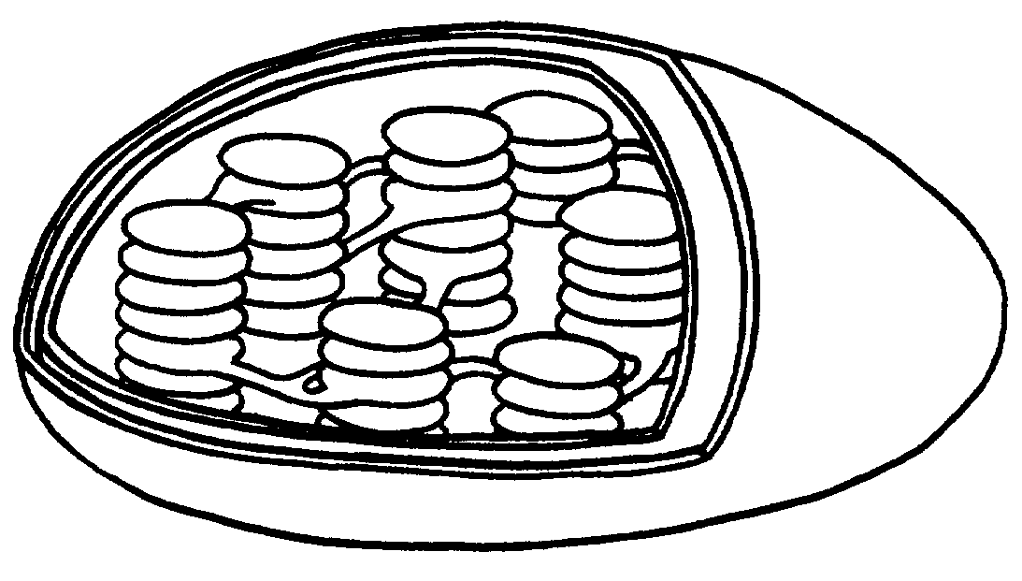
Chlorophyll
Read and Answer: Chlorophyll pigments are found inside the thylakoids. These pigments absorb the light energy used in photosynthesis.
Label diagram: to show where chlorophyll pigments are found.
Electromagnetic Light Spectrum
Photosynthetic organisms use only a small portion of the electromagnetic spectrum called “visible light”. Photosynthetic organisms contain pigments such as chlorophyll and carotenoids that capture the electromagnetic visible light waves. The color of the pigment comes from the wavelengths of the light reflected back. Plants appear green because the pigment chlorophyll reflects the yellow and green light waves back. Orange plants such as carrots, cantaloupe and sweet potatoes appear orange because the pigment carotenoid reflects the yellow and orangerays back. Blue, purple and red light waves are absorbed by chlorophylland carotenoids and provide the energy needed for the process of photosynthesis.

List two pigments used by plants to capture visible light waves: _________________________________

Why are plants green? __________________________________________________________________

Which light rays are absorbed by chlorophyll? _______________________________________________

Illustrate:Using colored pencils show light rays of blue, purple, red, yellow and green interacting with the chloroplast. Make sure to show which would be absorbed and which would be reflected back.
Details of Photosynthesis
Read and Answer: Photosynthesis depends on an interaction between two sets of chemical reactions: the “Light Reactions” and the “Calvin Cycle”. The Light Reactions require sunlight, which is why they are called the “Light Reactions”. The chemical reactions that take place in the Calvin Cycle do not require light, so the Calvin Cycle is sometimes called the “Dark Reactions” or the “Light Independent Reactions”.

What are the two types of chemical reactions that take place during photosynthesis?

1. ______________________________ & 2. _____________________________________

Why are the chemical reactions in the Calvin Cycle sometimes referred to as the dark reactions?

____________________________________________________________________________.

The Light Reactions
Chlorophyll, responsible for the light reactions, is built into the thylakoid membranes, also called “the electron transport chain”. Note: It is called the electron transport chain because the light excites electrons in the thylakoid membrane providing the energy that starts a chain of reactions. Chlorophyll absorbs light energy, followed by chemical reactions that convert the light energy into chemical energy in the form of ATP and NADPH. The ATP provides energy and the NADPH carries electrons to the Calvin Cycle.

What part of the chloroplast do the Light Reactions take place? _________________________

What is the thylakoid membrane also called? ________________________________________

The Calvin Cycle (Also Known as Light-Independent or Dark Reactions)
The enzymes that catalyze the Calvin cycle are located in the stroma. Using energy and electrons from the Light Reactions, the Calvin Cycle converts carbon dioxide to sugar during three phases: 1 carbon fixation, 2 Reduction, 3 Regeneration.

What part of the chloroplast does the Calvin Cycle take place in? _________________________

What are the three phases of the Calvin Cycle?

1. _______________________________________________

2. _______________________________________________

3. _______________________________________________

Photosynthesis Model
Use this diagram of photosynthesis to answer the questions below.
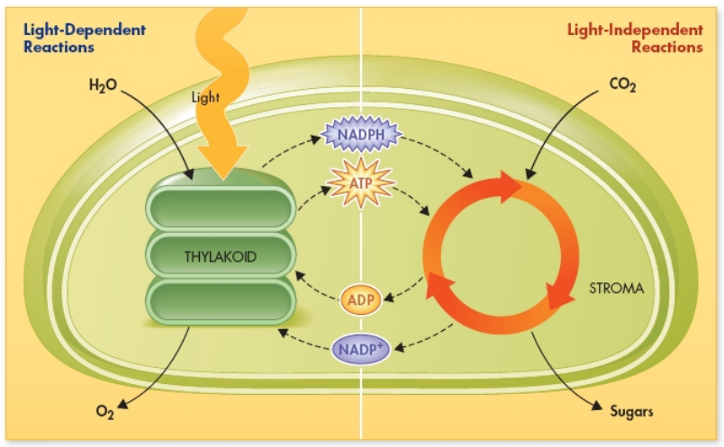
What organelle is pictured (the organelle photosynthesis takes place in)? _________________________________
Where do the Light Reactions take place (what part of the chloroplast)? __________________________________
What two reactants are absorbed in the light reactions? _______________________________________________
What product of the Light Reactions leaves the chloroplast? ____________________________________________
Label the Calvin Cycle.
What 2 products of the Light Reactions move to the Calvin Cycle _________________________________________
What reactant from the atmosphere is absorbed in the Calvin Cycle? _____________________________________
What 2 reactants used in the Calvin Cycle come from the Light Dependent Reactions? _______________________
What product from the Calvin Cycle leaves the chloroplast? _____________________________________________
What 2 products from the Calvin Cycle travel to the thylakoids? _________________________________________
The Calvin Cycle is illustrated with three arrows representing the three phases of the cycle. Label the three phases.

Cellular Respiration
Objectives
Know that glycolysis happens in the cytoplasm
Know that glycolysis breaks a six carbon sugar into 2 three carbon sugar molecules
Know that cellular respiration takes place inside the mitochondrion after glycolysis has taken place
Know the cellular respiration equation
Know the reactants and products of cellular respiration
Know the difference between aerobic and anaerobic processes
Overview of Cellular Respiration
Lecture Notes: Cellular respiration occurs inside the __________________________.

Cellular respiration is the process by which the chemical energy of food molecules, especially _______________ (or sugar), is converted into _______________.

Cellular respiration consists of a series of chemical reactions that require oxygen and sugar. The products of cellular respiration are water, carbon dioxide and 36-38 molecules of ATP.
Based on this information, complete the equation for cellular respiration:
_____________ + _____________ = _________________, __________________ & ________________

Mitochondria
Read and Answer: Mitochondria are known as the “power house” of the cell since they are the main energy source for cells. During the process of cellular respiration, mitochondria produce 36-38 molecules of ATP at a time.

Why are mitochondria known as the “power house of the cell”? __________________________________________________________________________________

How many molecules of ATP do they produce? ________________________

What biochemical process takes place inside the mitochondria? ______________________________

Mitochondria are membrane bound organelles found in of plant, animal (including human) and fungal cells. Mitochondria have an outer membrane and a folded inner membrane. The folds in the inner membrane are known as “cristae”. The space inside the inner membrane is called the “matrix”. The mitochondria has an electron transport chain similar to the electron transport chain found in chloroplasts. The electron transport chain of the mitochondria is located in the inner membrane. Chemical reactions known as the “Krebs Cycle” take place in the matrix.

Label Diagram: Based on what you have just read, label the outer membrane, inner membrane, cristae, matrix, electron transport chain and Krebs Cycle. Color the matrix blue.

Diagram of a Mitochondrion (Plural = Mitochondria)

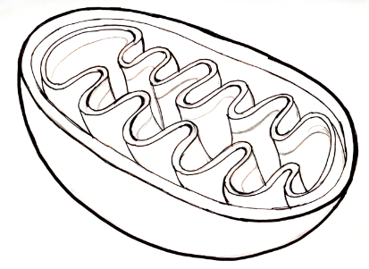

Details of Cellular Respiration
Cellular respiration can be divided into three metabolic processes:
1. Glycolysis 2. The Krebs cycle 3. Oxidative phosphorylation via the electron transport chain

1. Glycolysis
Glycolysis occurs in the cytosol or cytoplasm just outside the mitochondria. The word glycolysis means “sugar splitting”. During glycolysis a glucose molecule is split in half. Glucose molecules have 6 carbons, so they are commonly referred to as 6-carbon sugars. Glycolysis spits the 6-carbon sugar into two 3-carbon sugars with the funny name of pyruvates. During glycolysis 2 molecules of ATP and 2 electron carrying NADH molecules are released. The ATP molecules are used as energy for the cell. The electron carrying NADH molecules and two 3-carbon pyruvate molecules enter the matrix of the mitochondria and are ready to begin the next phase of cellular respiration, the Krebs Cycle. No oxygen is required for this process, so it is known as an anaerobic process.
Where does glycolysis occur (give both names)? _________________________________________
What does the word “glycolysis” mean? ________________________________________________
How many carbons does a molecule of glucose have? _____________________________________
What does glucose split into? ________________________________________________________
How many molecules of carbon are in a pyruvate? _______________________________________
How many molecules of ATP does glycolysis yield? _______________________________________
Does this process require oxygen? ____________________________________________________
What term is used for processes that do not require oxygen? ______________________________
Turn back to the diagram of the mitochondrion. Illustrate a 6-carbon sugar being split into two 3-carbon pyruvates in the cytosol or cytoplasm just outside the mitochondria.

2. Krebs Cycle
The next phase of cellular respiration requires oxygen, so it takes place inside the mitochondria where oxygen is stored. This phase is considered aerobic because it requires oxygen.

After entering the matrix of the mitochondria, the two 3-carbon pyruvate molecules undergo a series of chemical reactions called the Krebs Cycle. The Krebs cycle produces 2 more ATP molecules, NADH electron carrying molecules and FADH2. The Krebs Cycle releases carbon dioxide as a waste product of these reactions. The NADH electron carrying molecules and FADH2 move on to the inner membrane of the mitochondria, known as the electron transport chain, where they will provide energy for the last phase of cellular respiration.

Does the Krebs Cycle require oxygen? _________________________________________________
What are process that require oxygen called? ___________________________________________
Where does the Krebs Cycle occur? ___________________________________________________
How many ATP are made during the Krebs Cycle? ________________________________________
What waste product is released from the Krebs Cycle? ____________________________________
3. Oxidative Phosphorylation via the Electron Transport Chain
The last phase of cellular respiration takes place in the inner membrane of the mitochondria where the most oxygen is stored in the mitochondria. The abundance of oxygen, together with the presence of ATP Synthase enzymes creates an environment where 34 molecules can be created. Oxidative phosphorylation is the metabolic process where enzymes, called ATP synthase, are used to combine oxygen with NADH and FADH2 resulting in 34 molecules of ATP. Water is released as a byproduct of the reactions that take place in the electron transport chain.

Does oxidative phosphorylation require oxygen? ____________________________________________
Is oxidative phosphorylation an anaerobic or aerobic process? _________________________________
Where does oxidative phosphorylation take place? __________________________________________
What is another name for the inner membrane of mitochondria? _______________________________
What enzyme synthesizes ATP? __________________________________________________________
How many molecules or ATP are created in the electron transport chain? ________________________
What byproduct is released from the electron transport chain? ________________________________

Cellular Respiration Model
Instructions:
1. Using the information you learned about cellular respiration, label the number of ATP molecules made in each of the three phases of cellular respiration.
2. Label the anaerobic process.
3. Label the aerobic processes.
4. How many total ATP molecules are made during cellular respiration? __________________________
5. How many glucose molecules are required to make the above number of ATP? ________________

Transfer of Energy
Objectives
Explain the connection between photosynthesis, cellular respiration and the food chain
Compare autotrophs to heterotrophs
Compare producers and consumers
Compare types of consumers: herbivores, carnivores, omnivores, detritivores and decomposers
Construct a food web showing proper energy flow from producers to consumers
Know the trophic levels
Explain 10% energy loss from heat and excretion at each trophic level
Identify trophic levels with the most and least energy available

The Energy Cycle
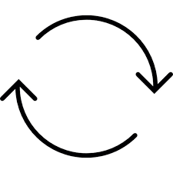

Insert Pogil Here

Insert Pogil Here

Elodea Lab
Materials
150 ml water
10ml Bromothymel Blue
3 zip lock baggies
2 branches elodea

Question 1: Does the elodea plant produce oxygen?
Hypothesis: _______________________________________________________________

Question 2: How is the rate of photosynthesis affected when plants are placed in a dark room?
Hypothesis: _________________________________________________________________

Control Group

Experimental Group 1

Experimental Group 2

Constants in an experiment do not change. What are the constants in this experiment?
_________________________________________________________________________
In a controlled experiment, one variable is changed to see if the results change. This variable is called the “independent variable”. What is the independent variable in Experimental Group 1?
___________________________________________________________________________
What is the independent variable in experimental group 2? ___________________________
The “dependent variable” is the variable that changes based on the independent variables.
What is the dependent variable in experimental group 1? ___________________________
What is the dependent variable in experimental group 2? ___________________________
Food Webs
Lecture Notes :

Producer/Autotroph:

Consumer/Heterotroph:

Food Web:
Shows the complex relationships between __________________ and __________________.

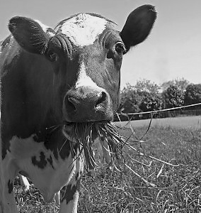
The arrows show the flow of ____________________

FROM the ___________________________

TO the ______________________________

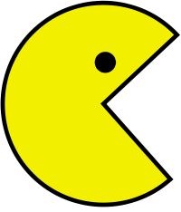

Types of Consumers

Herbivore:

Carnivore:

Omnivore:

Detritivore:

Decomposer:

Why are detritivores and decomposers so important?_________________________________
______________________________________________________________________________
Digital Assignment - Energy Transfer
Complete the “Energy Transfer” assignment posted in Google Classroom.

Energy Pyramid

Energy _____________ in a food chain is shown in an energy pyramid.

The pyramid shape illustrates that ________ energy is available at the _____________________ of the food chain than the top.

Energy pyramids are divided into ________________________ _______________________. Trophic means related to “feeding and nutrition”.

Each trophic level offers ______________ energy than the level below.

Organisms use approximately _________________ of their energy in _____________________, so only ________________ is passed on to the next level, or link in the food chain.

The energy used is released as ___________________.
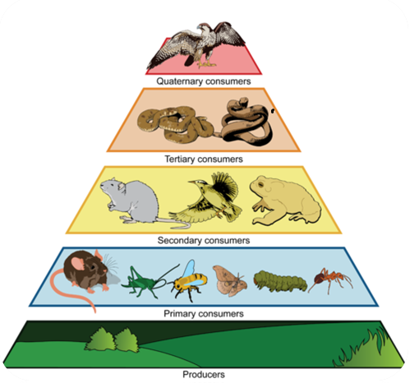

Instructions
1. Use a marker to circle and label a producer, primary consumer, secondary consumer and tertiary consumer in the same food chain.
2. Draw arrows showing the flow of energy.
3. Label the amount of energy available to each level.

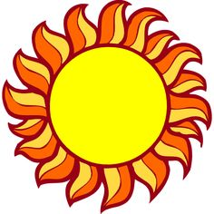
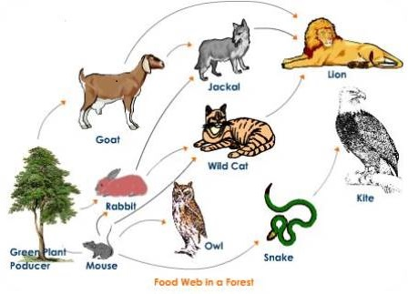

Critical Thinking Questions
Which of the following is a producer?
A. Fox
B. Lizard
C.Cactus
D. Scorpion

A cell contains both chloroplasts and mitochondria. Which conclusion can you draw about this organism?
A. It is a heterotroph
B. It does not have a metabolism
C. It carries out photosynthesis and cellular respiration
D. It gets its energy by consuming other organisms and food
Animal cells do not contain chloroplasts. What does this indicate about how animals must get the sugars they need to produce chemical energy that their cells can use?

What process in the human body transfers the energy from eating food to ATP?
A. Photosynthesis
B. Cellular respiration
C. Translation
D. Transcription

The Yellowstone area contains a great variety of organisms, including plants, algae, moss, fungi, blue jays fish and grizzly bears. Which sequence best represents the transfer of matter and energy through the Yellowstone ecosystem?
A. fungi to moss to algae to fish
B. blue jay to moss, to fungi to plant
C. algae to fish to grizzly bear to fungi
D. plant to blue jay to algae to grizzly bear

Which food chain is possible?
A. consumerconsumer producer
B. consumer producer consumer
C. producer consumer consumer
D. producerproducer consumer

Which of the following shows the flow of energy within an ecosystem?
A. cladogram
B. dichotomous key
C. food web
D. punnett square

How would the grasshopper be classified in the following food chain?
Plants grasshopper rats owls
A. producer
B. primary consumer
C. tertiary consumer
D. secondary consumer

In which trophic level is there the LEAST amount of energy available?
A. producer
B. tertiary consumer
C. primary consumer
D. secondary consumer

What would happen to an ecosystem if the detritivores and decomposers suddenly disappeared?
A. There would be more producers
B. There would be more carnivores
C. Dead organisms would take over the ecosystems of our planet

What is the maximum percent of energy available to a wolf that consumes a field mouse (herbivore)?
A. .1%
B. 1%
C. 10%
D. 100%
Which of the following describes metabolism?
A. Chemical reactions in the body that produce energy
B. Chemical reactions in the body that store and release energy
C. Chemical reactions in the body that make and destroy material
D. All of the above

Why isn’t 100% of the sun’s energy available to consumers?
A. 100% of the sun’s energy is available to consumers
B. Most is used up by metabolism and lost by heat
C. Some producers are not eaten when they are alive, so not as much energy transfers

