Name_________________________________________Block_______

Theory of Evolution Unit
- Evolution and Natural Selection
- Theories of the Origin of Life on Earth (Single Cell 4 Billion Years Old)
- Multicellular Life
- Anatomical and Molecular Evidence of Relationships
- Classification

Evolution and Natural Selection
Objectives
Explain that the theory of evolution is a theory about how living things evolved from simple to more complex forms over time
Describe how organisms with beneficial traits are more likely to survive, reproduce and pass on their genetic information
Compare “artificial selection” and “natural selection”.

Notes

Darwin and Natural Selection

- The theory of evolution is a theory about how living things evolved from _____________________ to ___________________ ____________________ forms over time.
- ____________________ ___________________ is known as “The Father of Evolution” because he proposed the idea of “_________________________ ______________________” as a mechanism or way for species to evolve or change over time, supporting the idea that all life might have evolved from a _______________________ ________________________.
- Natural Selection theprocess by which organisms that can ________________ to changes in their environment are able to ___________________________________________________.

4 Principles of Natural Selection
1.Variation:There must be ______________________ within a population that is _________________________.
- ____________________________ is difference within a population.
2.Adaptation: There must be a certain ______________________ that allows the organism to _________________ when it _____________________ against its environment.

- An __________________________ is a feature that allows an organism to better survive in its environment.
3. Overproduction: There must be an overproduction of offspring resulting in _____________________
4. Decent with Modification: There must be ________________________ _______________________ of descendents with adaptations suited for their environments.

Peppered Moth Illustration
1. What was the variation in the moth population?

2. What was the adaptation in the moth population?

3. What resource was limited due to overcrowding?

4. How were the descendants modified?

5. Later, pollution was controlled. What do you think happened to the moth population then?

6. Predict what would have happened to peppered moths if the pollution was a worldwide problem?

EdPuzzle Videos in Google Classroom
Watch the following videos and answer questions as prompted:
- What is Evolution?- by Stated Clearly
- What is Natural Selection?- by Stated Clearly
- Does the Theory of Evolution Really Matter? - by Stated Clearly

POGIL
- Evolution and Selection
Name __________________________________________________________ Lab ____
Origin of Life and Evidence of Evolution

Objectives
Understand there are various hypothesis about the origin of life
Explain the role cyanobacteria played in the origin of life on Earth
Understand the hypothesis of Endosymbiotic theory resulting in multicellular life
Understand the fossil record establishes there was life on earth in the form of bacteria approximately 4 billion years ago
Use anatomical and molecular evidence to establish evolutionary relationships among organisms.

NOTES

From Inorganic to Organic
How did something _________________ (organic) arise from something _______________(inorganic)?

Miller-Urey Experiment
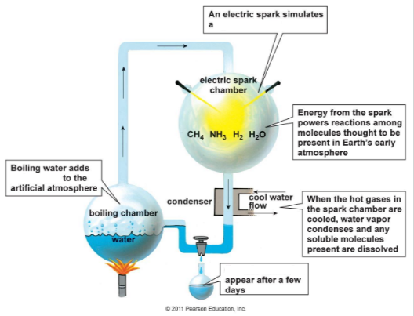
Fill in the blanks:

Meteorite Hypothesis
In 1969 a meteorite crashed into Murchison, Australia. Scientists found the meteorite contained over 90 _______________________, 19 of which have been found on Earth, remember all of life is made up of ____________ amino acids. This resulted in the “Murchison Hypothesis” that life may have originated from amino acids in a meteorite.

Primordial Soup Hypothesis
The Primordial Soup hypothesis suggests that life began in a __________________________________ as a result of the combination of chemicals from the atmosphere and some form of energy to make _________________________, the building blocks of ___________________________, which would then evolve into the first life on Earth.

Deep-Sea Vent Hypothesis
The deep-sea vent hypothesis suggests that life may have begun deep within the ocean where ____________________________ spewed key hydrogen-rich molecules. Their rocky nooks could then have concentrated these molecules together and provided mineral catalysts for critical reactions.

The Fossil Record
________________________ are single-celled prokaryotes thought to be the first living organisms on Earth. The fossil record estimates they were in existence ____________________________years ago.

Earth’s Atmosphere is Oxygenated
These ____________________ may have formed Stromatolites and released ______________________ through __________________________ creating an atmosphere in which life could survive.

From Single Celled to Multicellular

How did a ______________________ organism arise from a _________________________ organism?

Endosymbiotic Theory
Endosymbiotic Theory suggests that eukaryotes were formed when prokaryotes were ____________________________ (or swallowed up) by larger prokaryotes and somehow survived instead of being digested. Some scientists believe that chloroplasts and mitochondria were formerly prokaryotes. This theory is based on several factors. Unlike other organelles, chloroplasts and mitochondria have their own DNA and ribosomes. They can make copies of themselves, they are about the same size as prokaryotes, and they have circular DNA similar to that of bacteria.

Homologous Structures

Homologous structures have the same bones suggesting ____________________common ancestors.

Analogous Structures and Convergent Evolution
Analogous structures have different bones but perform the same function. This suggests __________________ _____________________, a process whereby organisms that are not closely related independently evolve _______________ ________________ as a result of having to _____________to similar environments.

Vestigial Structures
Remnants of an organ, __________________________________ that had a function in an earlier ancestor. Examples: ___________________________, _______________________________

Embryology
Similarities in __________________________ development suggest common ancestry

Molecular Biology
Study of living things at the molecular level such as ________________, RNA and proteins.
This is useful in determining how closely related ancestors may be.
Molecular Evidence
Background information: DNA is transcribed into RNA. RNA codes for amino acids that build proteins.

Amino Acid Sequencing
This is a chart of amino acid sequences for eight mammals. Each letter stands for a different amino acid. The numbers at the top of the chart indicate where each amino acid is located on the protein chain.

Instructions: Compare the amino acid sequences between seven animals and the human. Circle any amino acid that is different than that of a human. Record the number of differences in the data table:

Data Table
Mammal | Number of Differences Amino Acid Sequence
Bear
Chimpanzee
Gibbon
Gorilla
Monkey
Mouse
Shrew

Location | 4 | 5 | 6 | 9 | 10 | 12 | 13 | 20 | 25 | 33 | 41 | 43 | 50 | 51 | 52
Human | T | P | E | S | A | T | A | V | G | V | F | E | T | P | D
Bear | T | G | E | S | L | T | G | V | G | V | F | D | S | A | D
Chimpanzee | T | P | E | S | A | T | A | V | G | V | F | E | T | P | D
Gibbon | T | P | E | S | A | T | A | V | G | V | F | E | T | P | D
Gorilla | T | P | E | S | A | T | A | V | G | V | F | E | T | P | D
Monkey | T | P | E | N | A | T | T | V | G | L | F | E | S | P | D
Mouse | T | D | A | A | A | S | C | S | G | V | Y | D | S | A | S
Shrew | S | G | E | A | C | T | G | E | A | V | F | D | S | A | S

Location | 54 | 56 | 58 | 68 | 69 | 70 | 71 | 72 | 73 | 75 | 76 | 77 | 80 | 87 | 104
Human | V | G | P | L | G | A | F | S | D | L | A | H | N | T | R
Bear | I | N | P | L | N | S | F | S | D | L | K | N | N | K | K
Chimpanzee | V | G | P | L | G | A | F | S | D | L | A | H | N | T | R
Gibbon | V | G | P | L | G | A | F | S | D | L | A | H | N | Q | R
Gorilla | V | G | P | L | G | A | F | S | D | L | A | H | N | T | K
Monkey | V | G | P | L | G | A | F | S | D | L | N | H | N | Q | K
Mouse | I | G | A | I | T | A | F | N | D | L | N | H | S | S | R
Shrew | V | G | P | L | H | S | L | G | E | V | A | N | N | K | R

Location | 109 | 110 | 112 | 115 | 116 | 117 | 118 | 121 | 125 | 126 | 130 | 139
Human | V | L | C | A | H | H | F | E | P | V | Y | N
Bear | V | L | C | A | H | H | F | E | Q | V | Y | N
Chimpanzee | V | L | C | A | H | H | F | E | P | V | Y | N
Gibbon | V | L | C | A | H | H | F | E | Q | V | Y | N
Gorilla | V | L | C | A | H | H | F | E | P | V | Y | N
Monkey | V | L | C | A | H | H | F | E | Q | V | Y | N
Mouse | M | I | I | G | H | H | L | D | A | A | F | T
Shrew | V | L | V | A | S | K | F | E | P | V | F | N

Questions
Based on your data, which mammal is most closely related to humans?

Based on your data, which is most distant from humans?

Ed Puzzle Videos in Google Classroom
Watch the following videos and answer questions as prompted:

- What is Chemical Evolution? by Stated Clearly
- What was that Miller Urey Experiment? by Stated Clearly
- How Does Genetic Information Evolve Part 1? by Stated Clearly

POGIL
Complete the “Evidence for Evolution” POGIL

Classification of Life
Three Domains
Instructions:
- Label Domain Eukarya, Domain Archaea and Domain Bacteria
- Label the node that indicates where life’s most common ancestor is located
- Circle the kingdom that includes humans
- Label the Eukaryotic Domain (all have cells with membrane bound organelles & a nucleus)
- Label the Prokaryotic Domains (cells have no membrane bound organelles & free floating DNA)
- Using arrows, show the crossover of mitochondria and chloroplasts into kingdom Eukarya

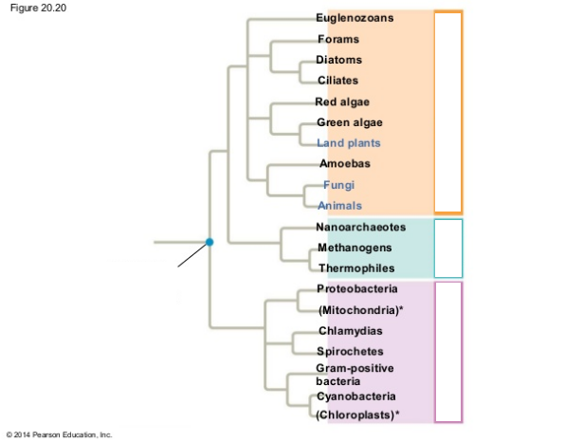

Cladistics
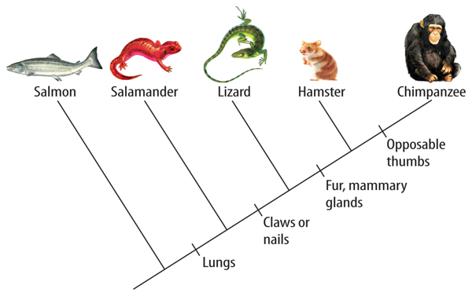
Cladistics
Cladistics is the processes of ____________________organisms based on common ancestry on a __________________.
Label the cladogram.

Clades
Each species branches out to a new _______________ on the cladogram.
Circle the clades on the cladogram.
How many clades are there?

Derived Characters
Derived characters are _____________ that differ in structure or function than traits found in ancestral line for a group of species.
What derived character caused a branch in the cladogram that separates the lizard from the hamster?

Node
Each place the branch splits is called a node. Nodes represent most common ancestors.
Circle the node where a salmon and salamander share the most common ancestor.

Linnaean System of Classification

Taxonomy

Taxon (plural = taxa)

Binomial Nomenclature

First part of the two part name is the _________________________

What are the rules of writing the first part of the name?

Second part of the two part name is the:

What are the naming rules of writing the second part of the name?

